**Unearthing the environmental impact of human activity : A Global CO2 emission analysis**

1. **INTRODUCTUION**

 Worldwide commitment to tackle the issue culminated in the United [Nations Paris Climate Agreement](http://unfccc.int/paris_agreement/items/9485.php) in December 2016, when 195 nations signed-up to limit their greenhouse gas emissions. However, to enable well-informed decision making for greenhouse gas emission reductions, and to monitor policy effectiveness, a comprehensive global greenhouse gas observing system is required. ****Monitoring carbon dioxide (CO2)**** has drawn most attention, due to its dominant role in climate change and the strong human hand in its emissions.In 2015, a [European Commission report](http://www.copernicus.eu/sites/default/files/library/CO2_Report_22Oct2015.pdf) considered a European capacity for monitoring anthropogenic CO2 emissions and concluded that a comprehensive observing system should be based on a combination of space-borne observations and ground-based monitoring networks.

The observing system must allow us to separate the impact of anthropogenic emissions from the effect of the complex natural carbon cycle, both affect atmospheric CO2 concentrations.

Observations from satellites, ground-based observation networks and aircraft provide CO2 information at specific times and locations, but alone do not constitute a continental to global monitoring capacity across different time scales. Moreover, these observations mostly measure atmospheric CO2 concentrations, which is an indirect measure of the underlying carbon emissions or uptake. Therefore, the use of an Earth System modelling infrastructure is required to combine Earth observations (ground-based, aircraft and satellite) with detailed CO2 emissions inventory data.

### OVERVIEW

Global warming is one of the biggest challenges currently being faced by the human race, although correlation is not causation, a likely cause of global warming is due to increased atmospheric carbon dioxide from human activities. CO2 Emission refers to the Carbon Dioxide emitted throughout the world. For this analysis we will be focusing on CO2 Emissions and its effect on the world we live in as well as some key factors and stats that may play a role in the emission of CO2 globally. Fossil fuel use is the primary source of CO2. The data throws light onto how much fossil fuels are burnt, per year per nation, which amounts to an increase in CO2 every year. This will help researchers and environment experts to predict global warming. So countries should set a goal to decrease this amount yearly. Analysing Global Co2 Emission across countries from 1975 to 2020. This dataset contains a record of Co2 Emission by each Country and Region of Earth, here we are going to analyse and visualise Country wise, Region wise and Overall Co2 Emission on Earth.

* 1. **PURPOSE**

Carbon dioxide is an important greenhouse gas that helps to trap heat in our atmosphere. Without it, our planet would be inhospitably cold. However, an increase in CO2 concentrations in our atmosphere is causing average global temperatures to rise, disrupting other aspects of Earth's climate

1. **Problem Defenition & Design Thinking**

Global warming is one of the biggest challenges currently being faced by the human race, although correlation is not causation, a likely cause of global warming is due to increased atmospheric carbon dioxide from human activities. CO2 Emission refers to the Carbon Dioxide emitted throughout the world. For this analysis we will be focusing on CO2 Emissions and its effect on the world we live in as well as some key factors and stats that may play a role in the emission of CO2 globally. Fossil fuel use is the primary source of CO2. The data throws light onto how much fossil fuels are burnt, per year per nation, which amounts to an increase in CO2 every year. This will help researchers and environment experts to predict global warming. So countries should set a goal to decrease this amount yearly. Analysing Global Co2 Emission across countries from 1975 to 2020. This dataset contains a record of Co2 Emission by each Country and Region of Earth, here we are going to analyse and visualise Country wise, Region wise and Overall Co2 Emission on Earth.

**2.1 Brainstorming Map**

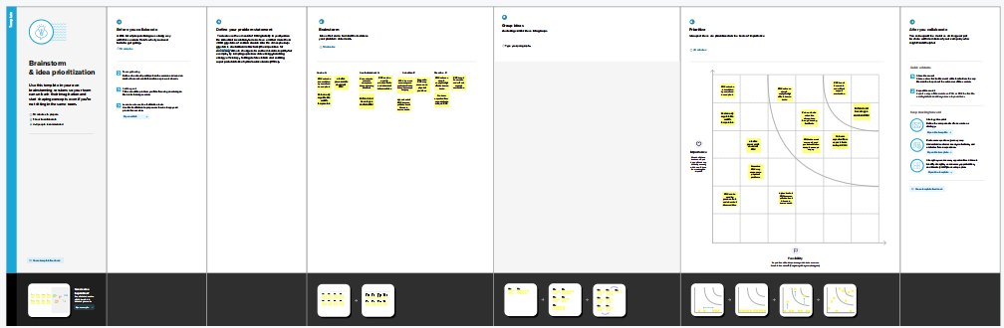

**2.2 Empathy Map**

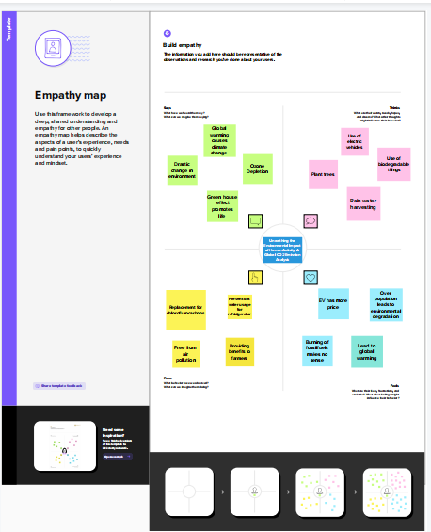

**3.RESULT**

**3.1 Data extraction & collection from database**

Data collection is the process of gathering and measuring information on variables of interest, in an established systematic fashion that enables one to answer stated research questions, test hypotheses, and evaluate outcomes and generate insights from the data.

Dataset consists CO2 emissions in metric ton per capita of every country around the world. The data is collected from 1975 to 2020. In this dataset Countries and regions are included. Data is initially pre-processed using excel.

Dataset consists CO2 emissions in metric ton per capita of every country around the world. The data is collected from 1975 to 2020. In this dataset Countries and regions are included. Data is initially pre-processed using excel.

***The dataset contains***

● Country- Country for which Co2 is Recorded

● Year- Year the data was recorded

● Co2 Emission (In Million Metric Tons )

● Co2 Growth per Capita

● Co2 Per Capita

● Cumulative Co2

● Several Fossil Fuels rate of Emission

**3.2 Data Visualization**

Data visualization is the process of creating graphical representations of data in order to help people understand and explore the information. The goal of data visualization is to make complex data sets more accessible, intuitive, and easier to interpret. By using visual elements such as charts, graphs, and maps, data visualizations can help people quickly identify patterns, trends, and outliers in the data.

The number of unique visualizations that can be created with a given dataset. Some common types of visualizations that can be used to analyze the Co2 Emission include bar charts, line charts, Tree Map, scatter plots, pie charts, Maps etc. These visualizations can be used to compare performance, track changes over time, show Emission, and relationships between variables, breakdown of factors and emission by countries and continenrts.

**3.2.1 Total world emission**

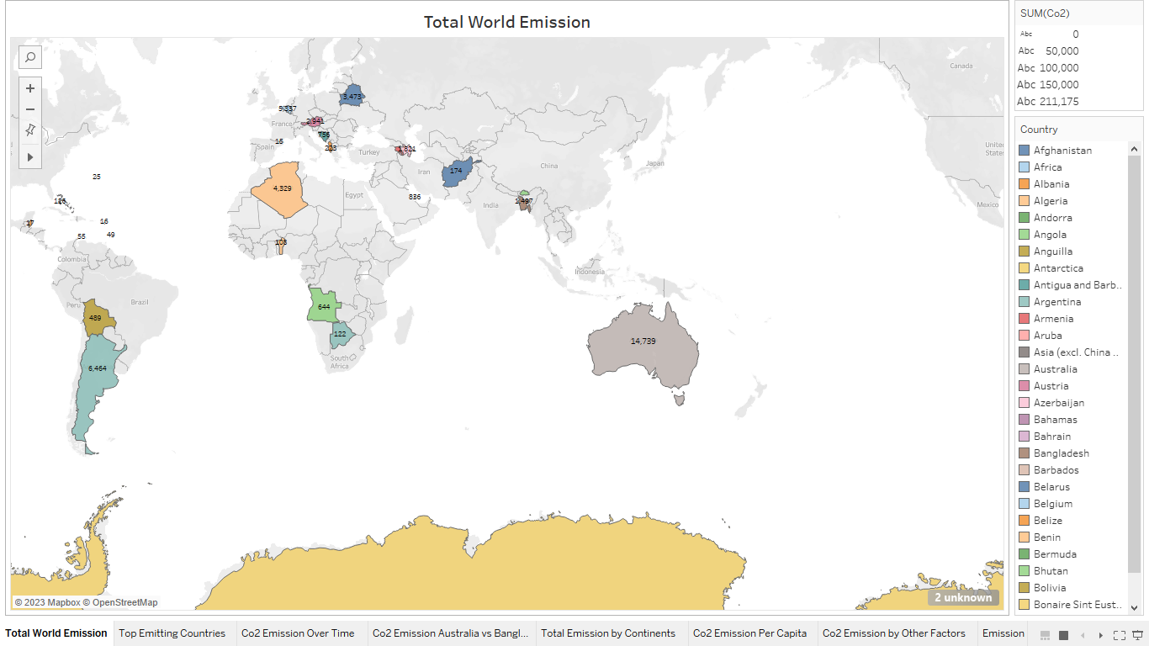

**3.2.2 Top emitting countries**

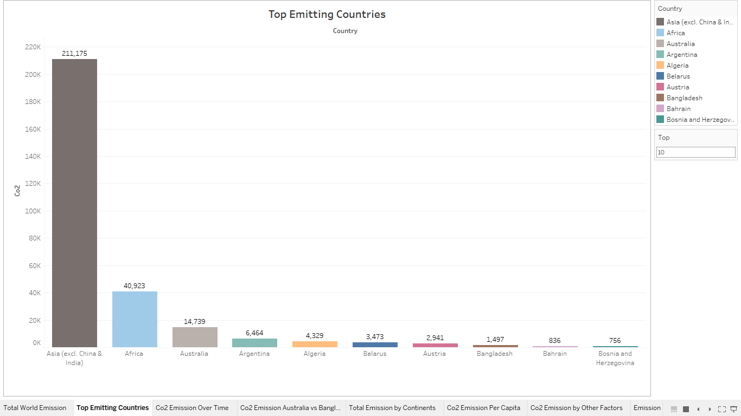

**3.2.3 Total CO2 emission over time**

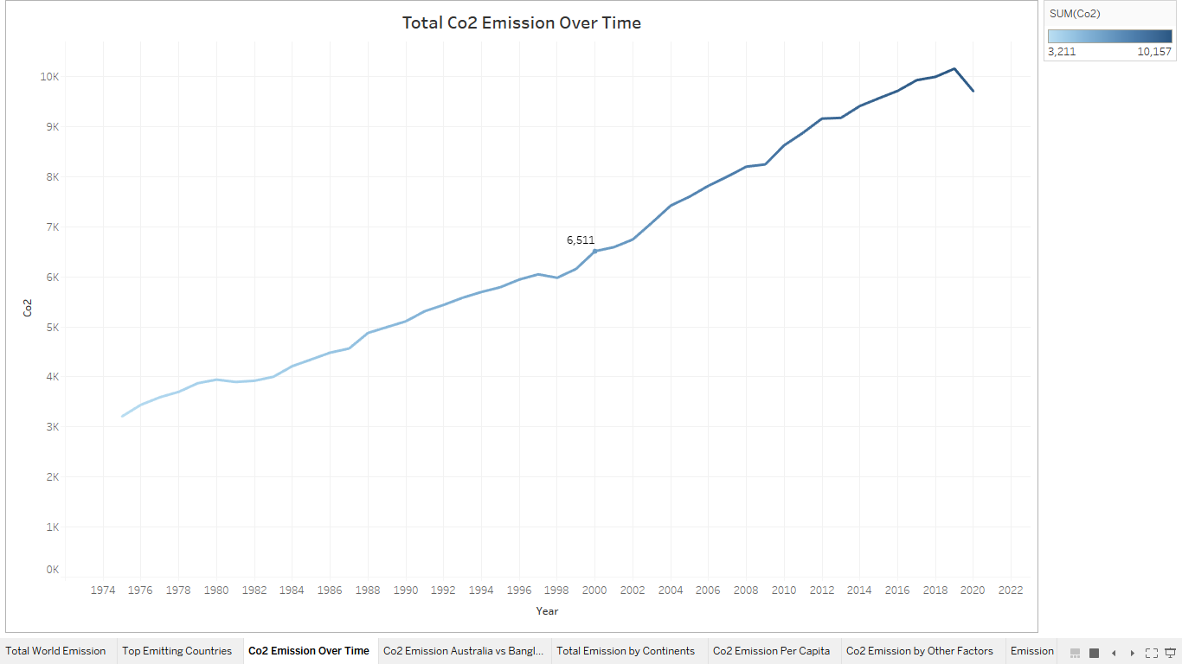

**3.2.4 CO2 Emission Australia vs Bangladesh**

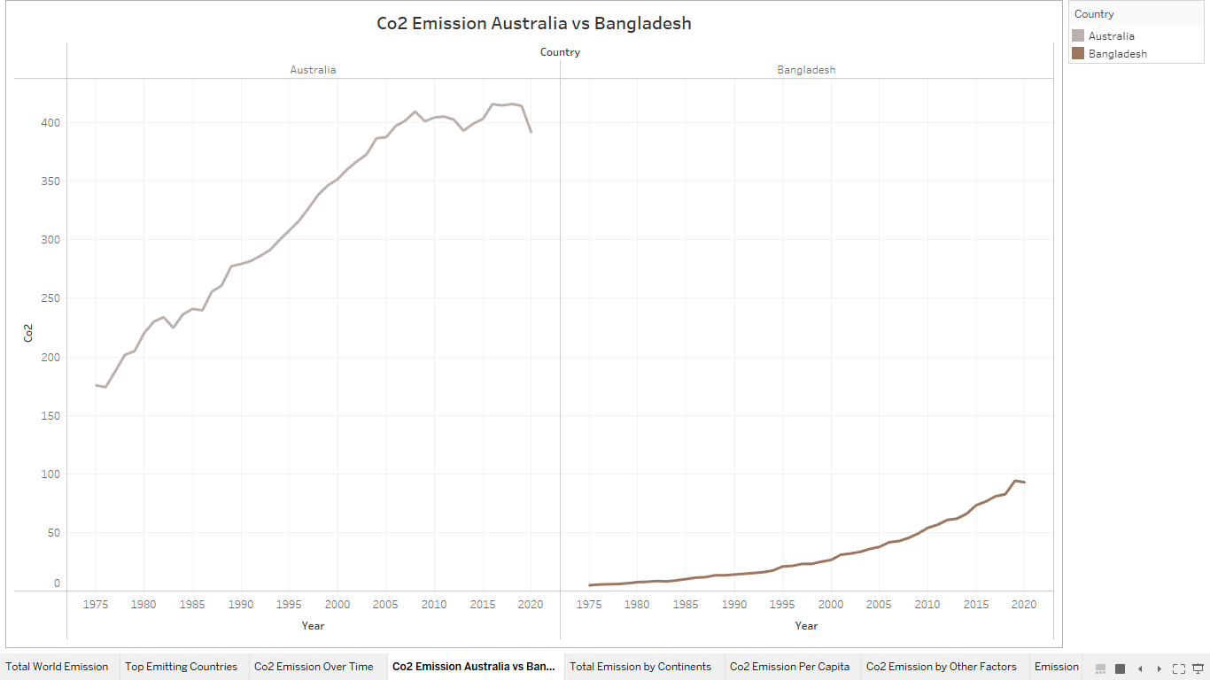

**3.2.5 Total Emission by continents**

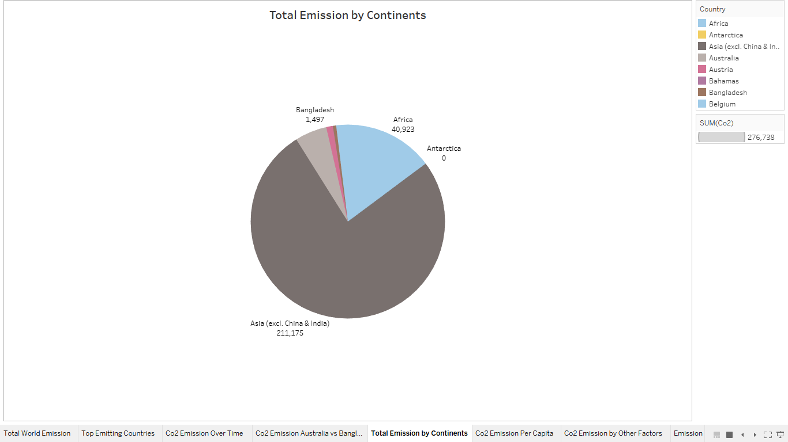

**3.2.6 Co2 Emissions Per Capita**

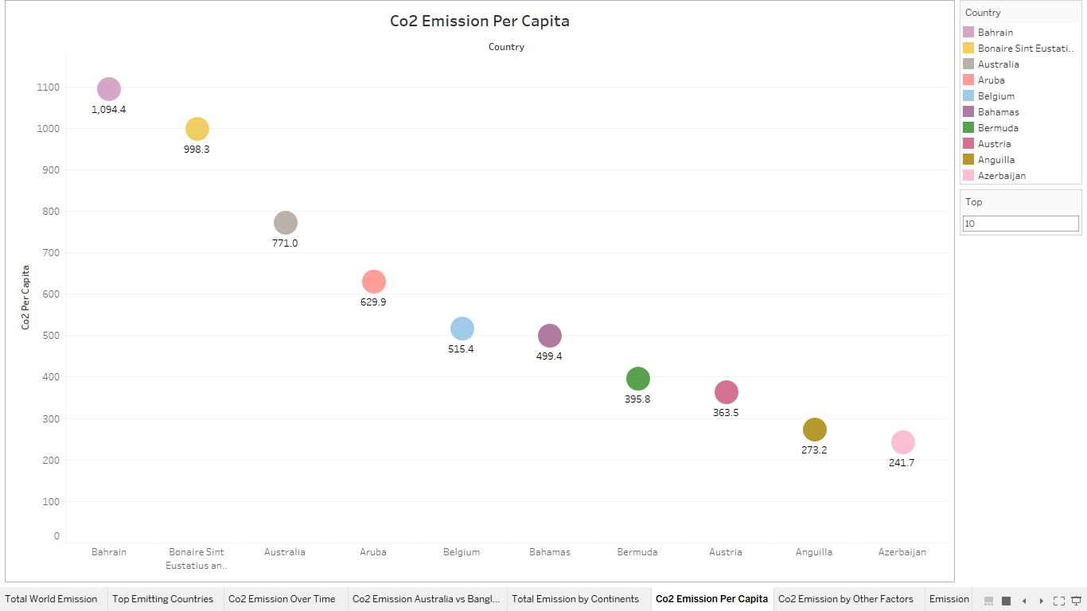

**3.2.7 Co2 Emission by other factors**

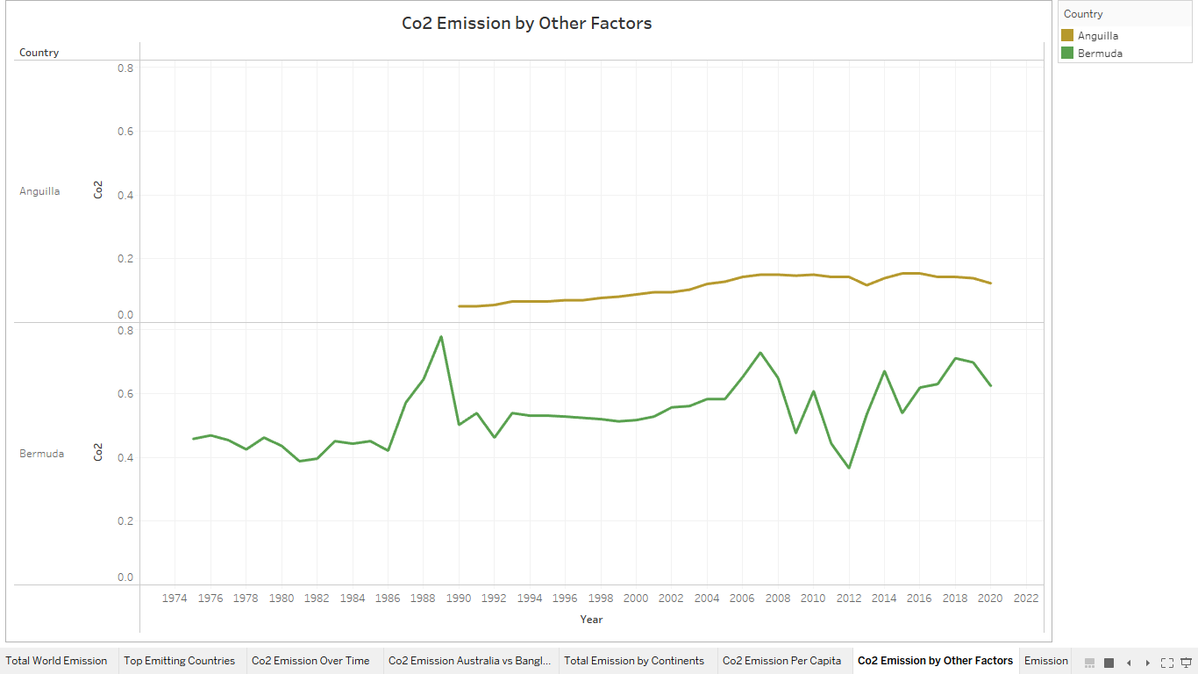

**3.2.8 Emission Rate by Internal Factors**

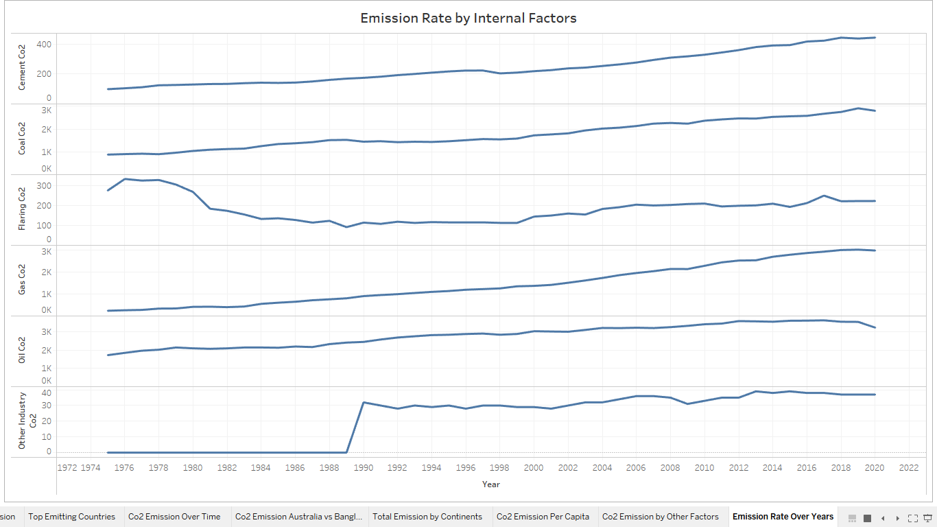

**3.2.9 Donut chart for coal co2**

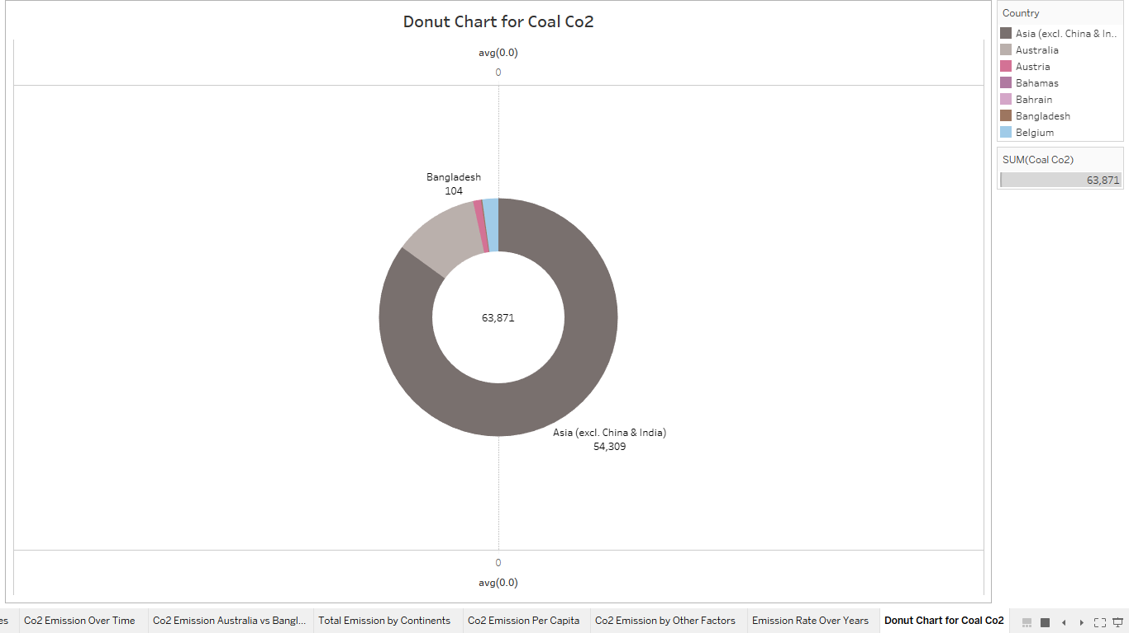**3.2.10 Donut chart for cement Co2 emission**

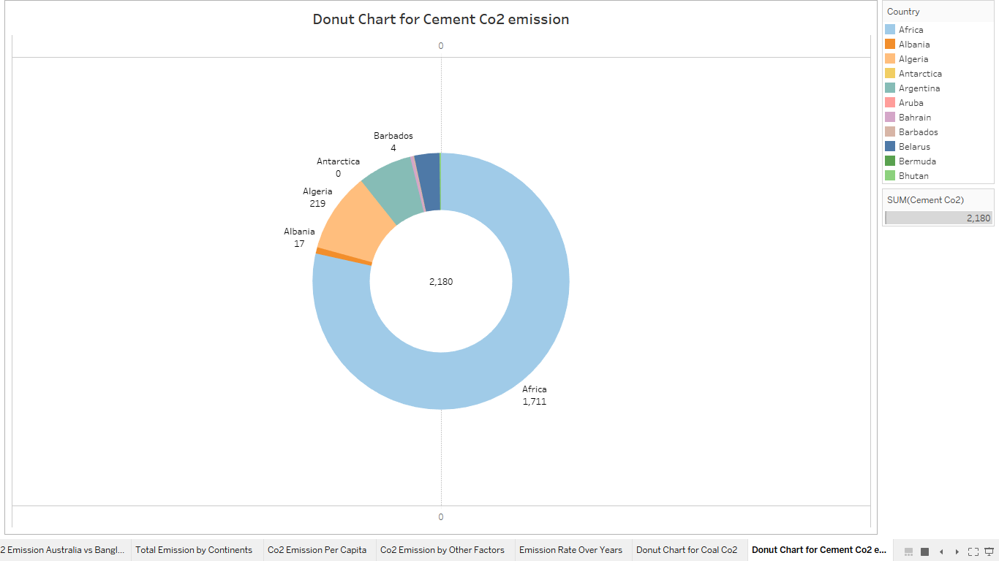

**3.2.11 Donut chart for Gas Co2 Emission**

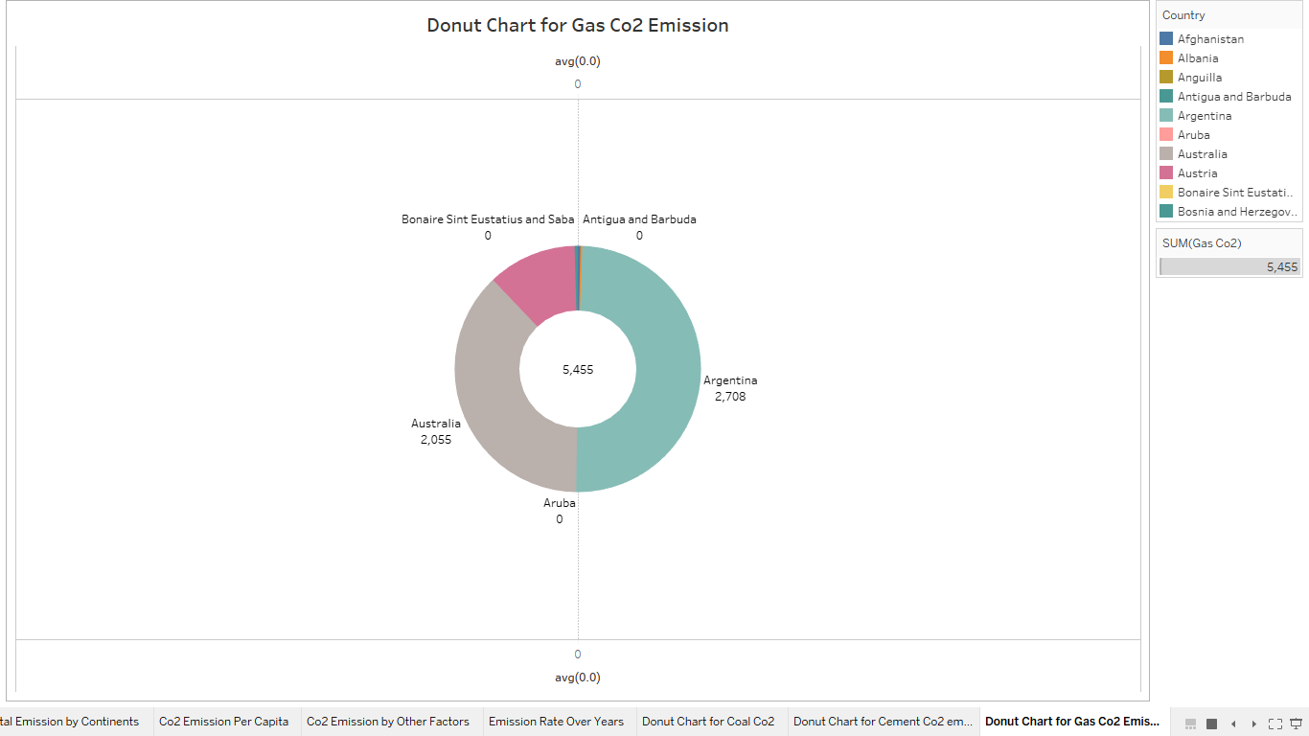

**3.2.12 Donut chart for flaring co2 emission**

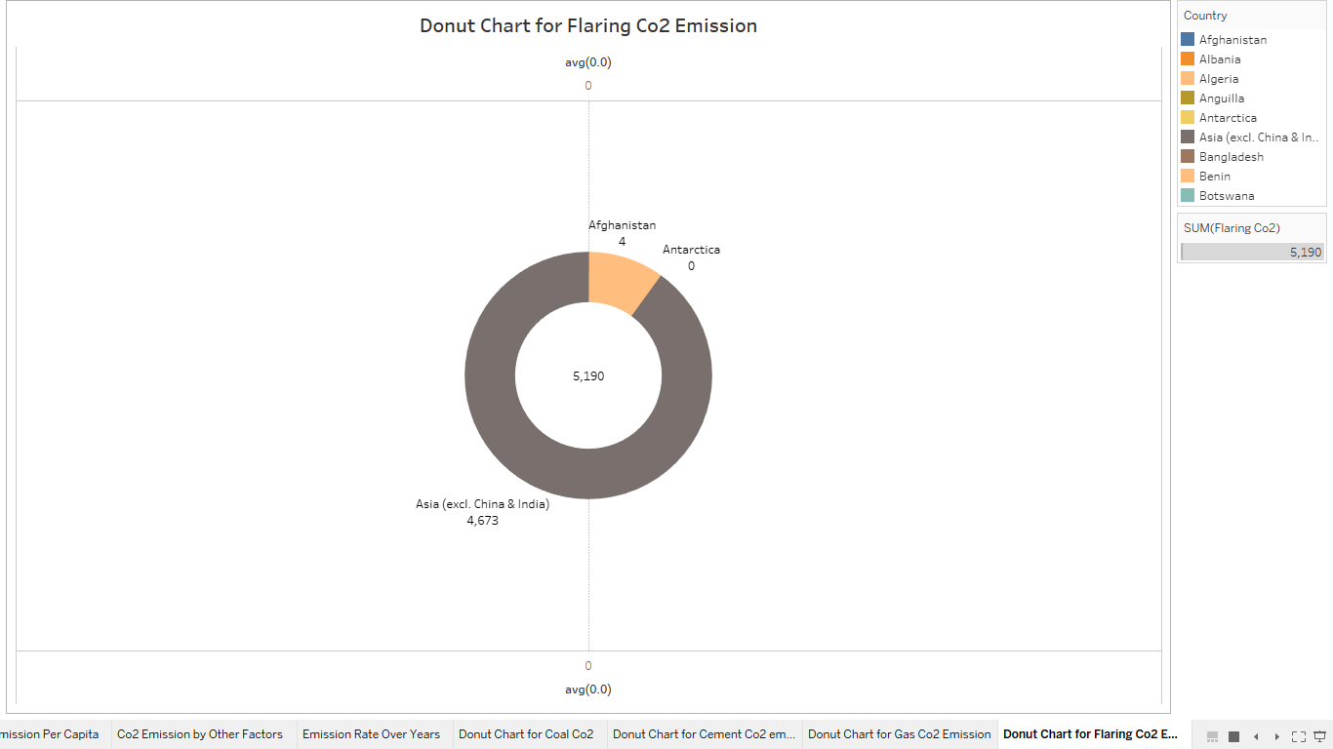

**3.2.13 Donut chart for Oil Co2 Emission**

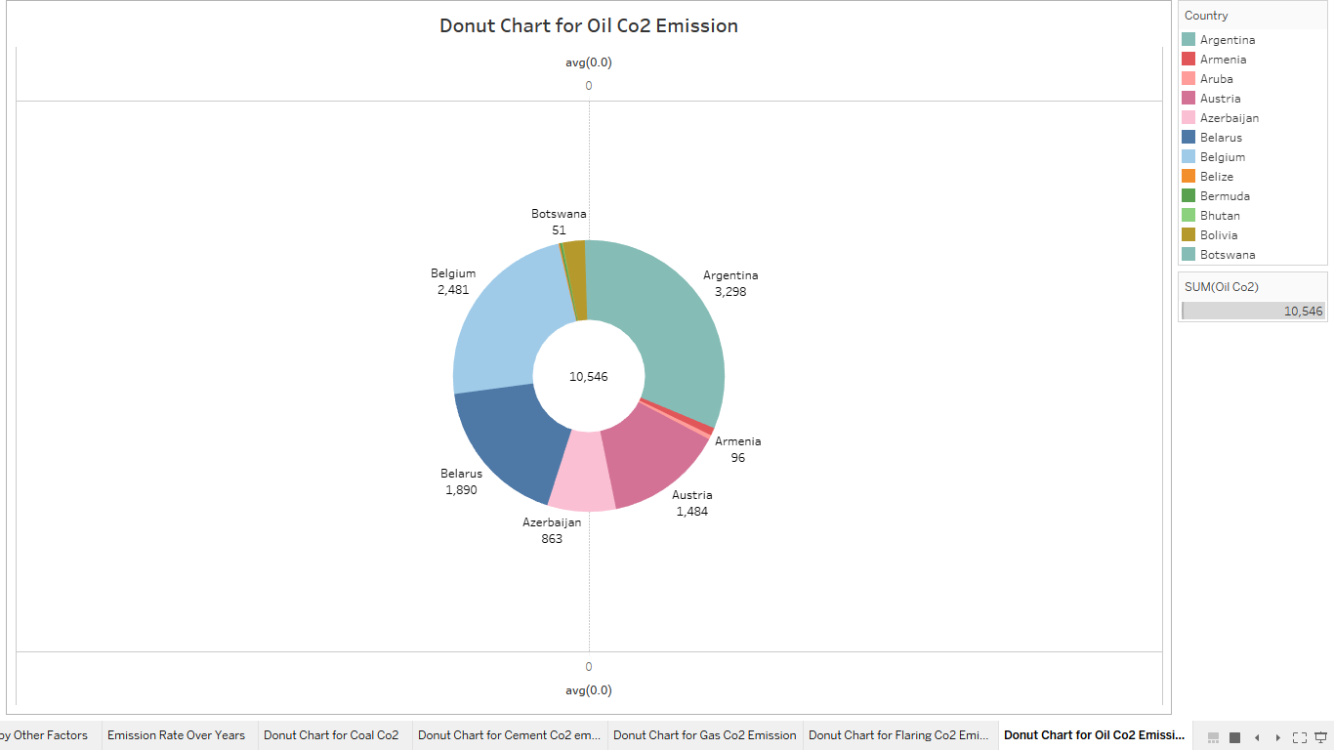

**3.2.14 Co2 Emission Over past 10 years**

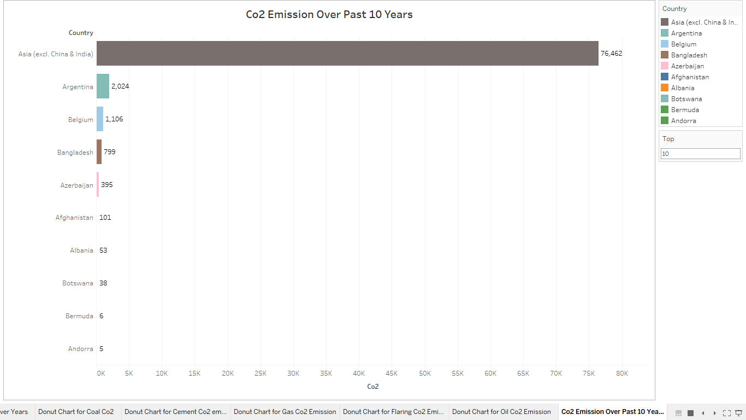

**3.2.15 Overall Contribution by Asia in Co2 Emission**

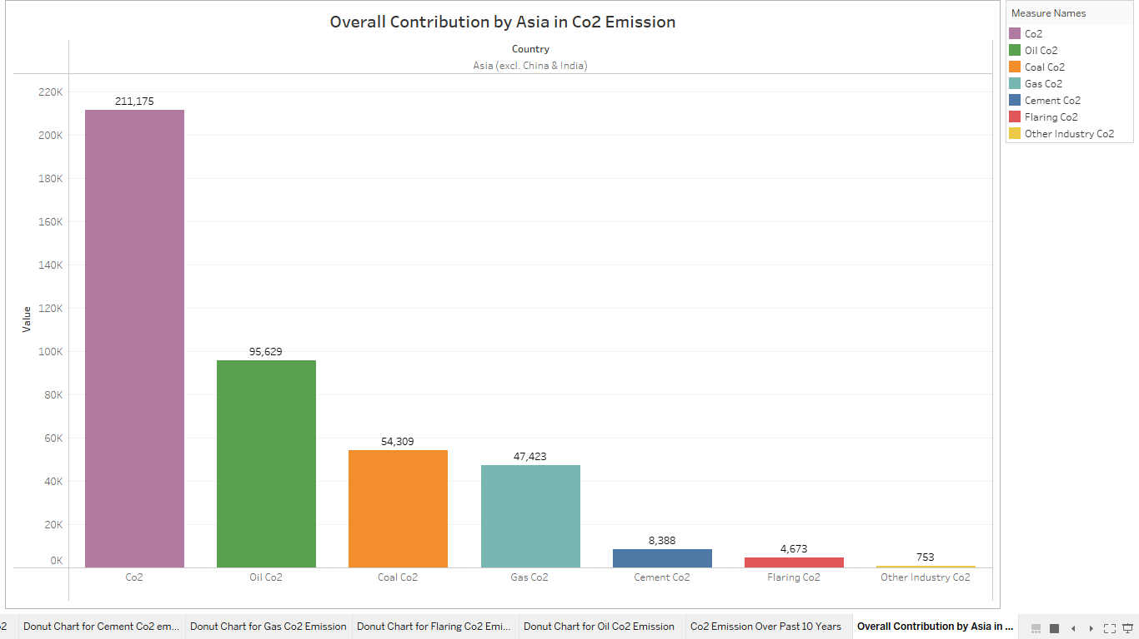

**3.2.16 Continent wise contribution by internal factors**

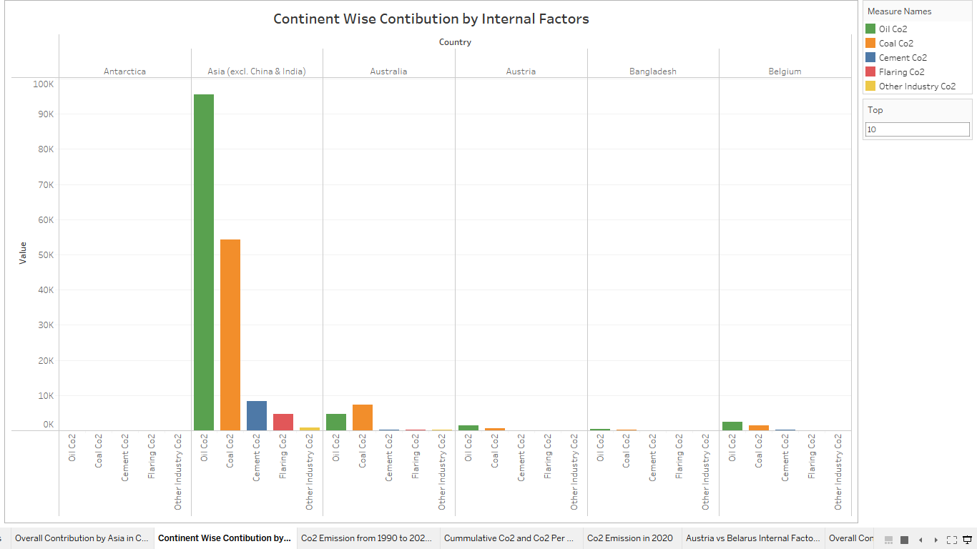

**3.2.17 Co2 Emission from 1990 to 2020 based on internal factors**

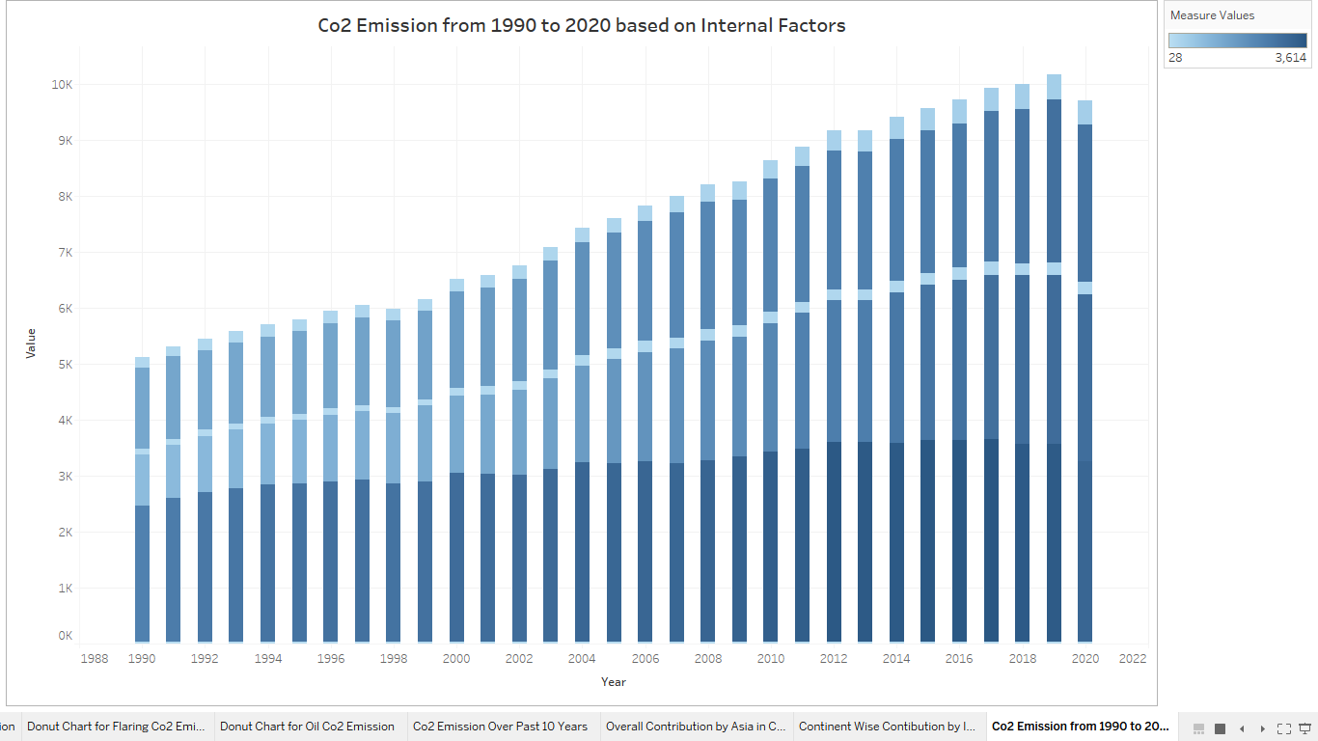

**3.2.18 Cummulative Co2 and Co2 Per Capita Over years**

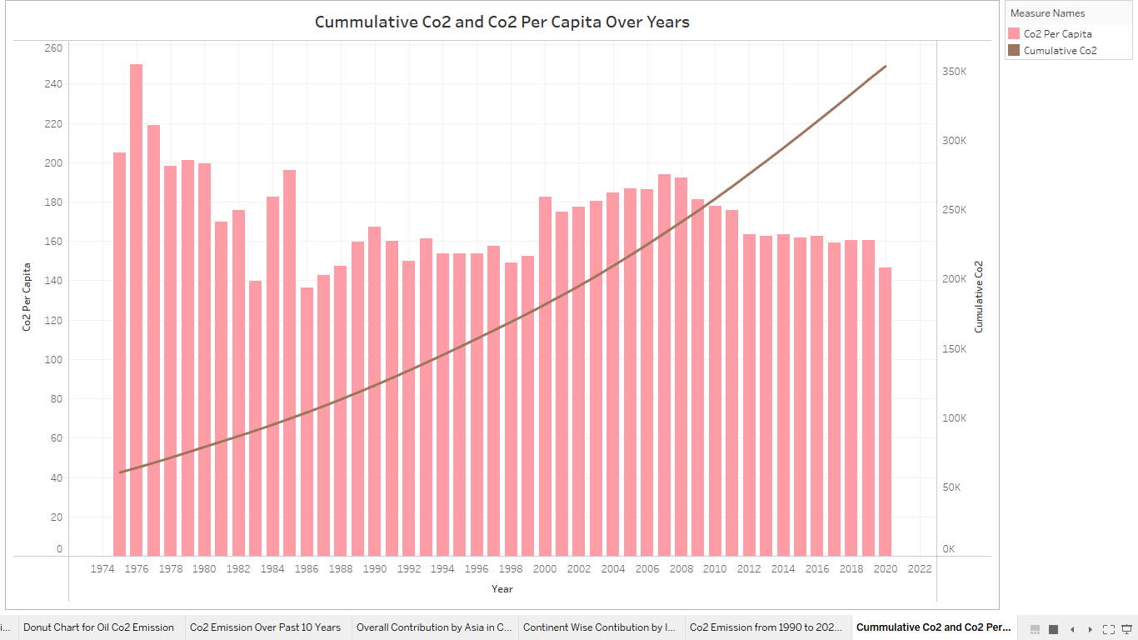

**3.2.19 Co2 in emission in 2020**

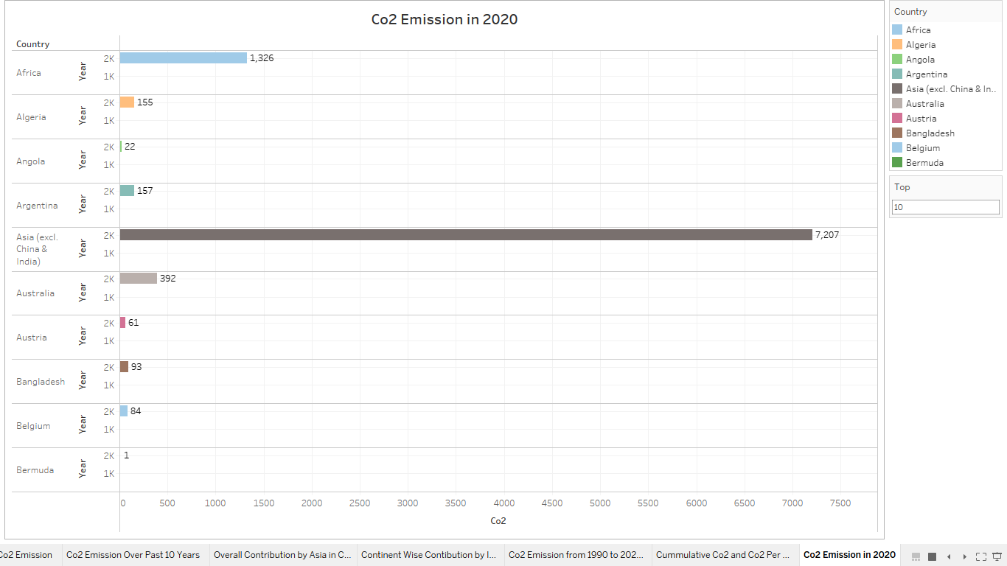

**3.2.20 Austria vs Belarus Internal Factors**

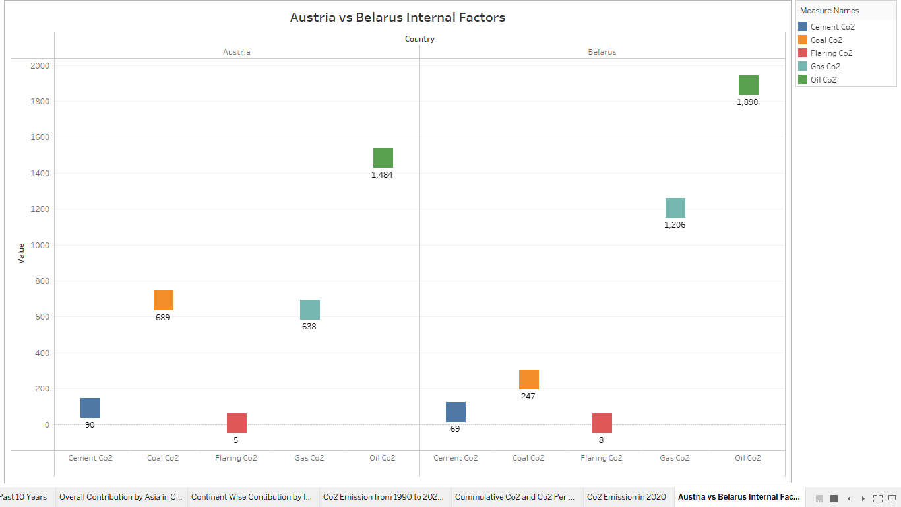

**3.2.21 Overall Contribution by Asia in Co2 Emission**

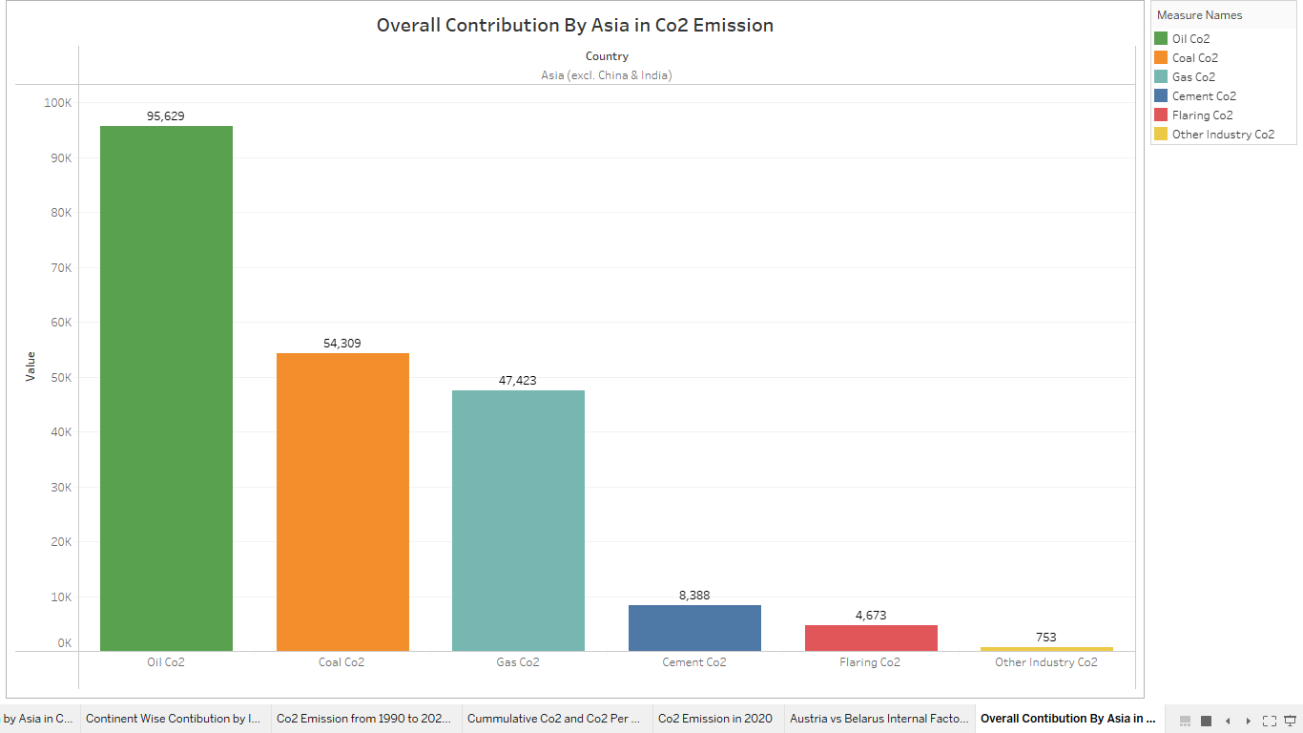

**3.3 Dashboard**

A dashboard is a graphical user interface (GUI) that displays information and data in an organized, easy-to-read format. Dashboards are often used to provide real-time monitoring and analysis of data, and are typically designed for a specific purpose or use case. Dashboards can be used in a variety of settings, such as business, finance, manufacturing, healthcare, and many other industries. They can be used to track key performance indicators (KPIs), monitor performance metrics, and display data in the form of charts, graphs, and tables.

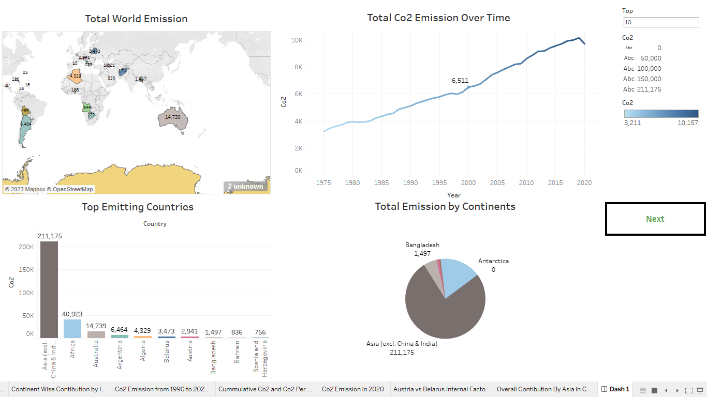

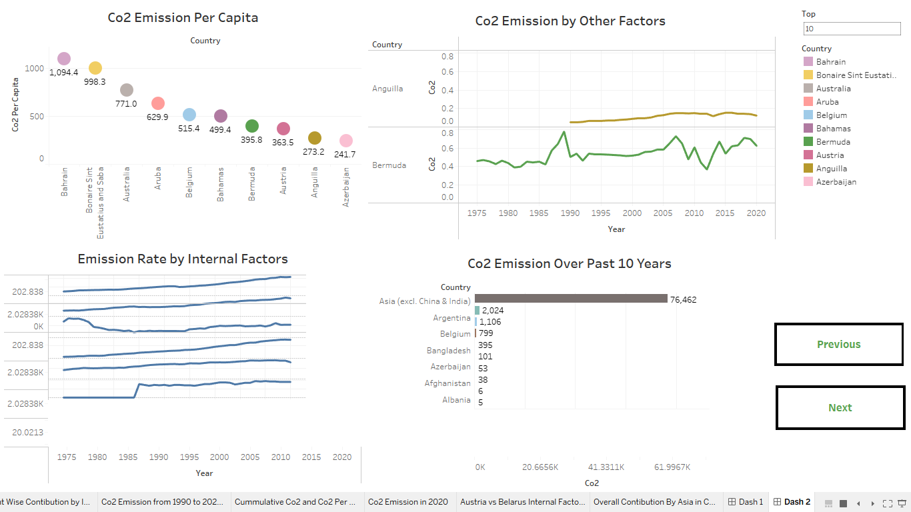

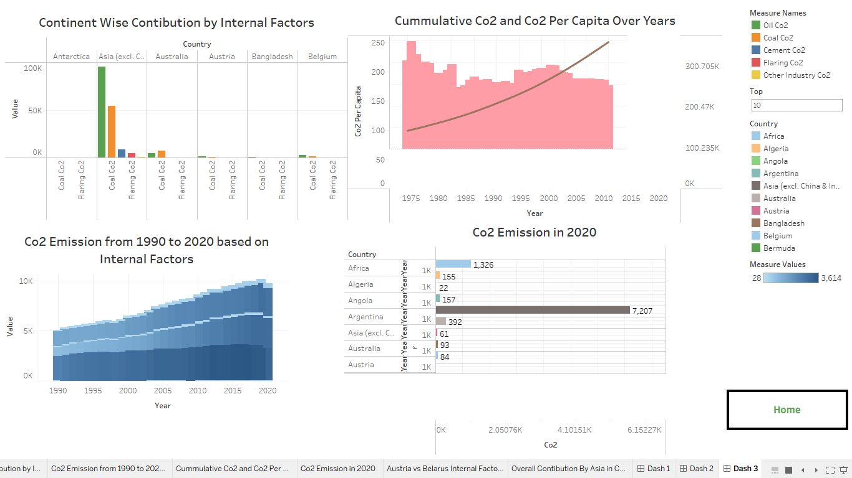

**3.4 : Story**

data story is a way of presenting data and analysis in a narrative format, with the goal of making the information more engaging and easier to understand. A data story typically includes a clear introduction that sets the stage and explains the context for the data, a body that presents the data and analysis in a logical and systematic way, and a conclusion that summarizes the key findings and highlights their implications. Data stories can be told using a variety of mediums, such as reports, presentations, interactive visualizations, and videos.

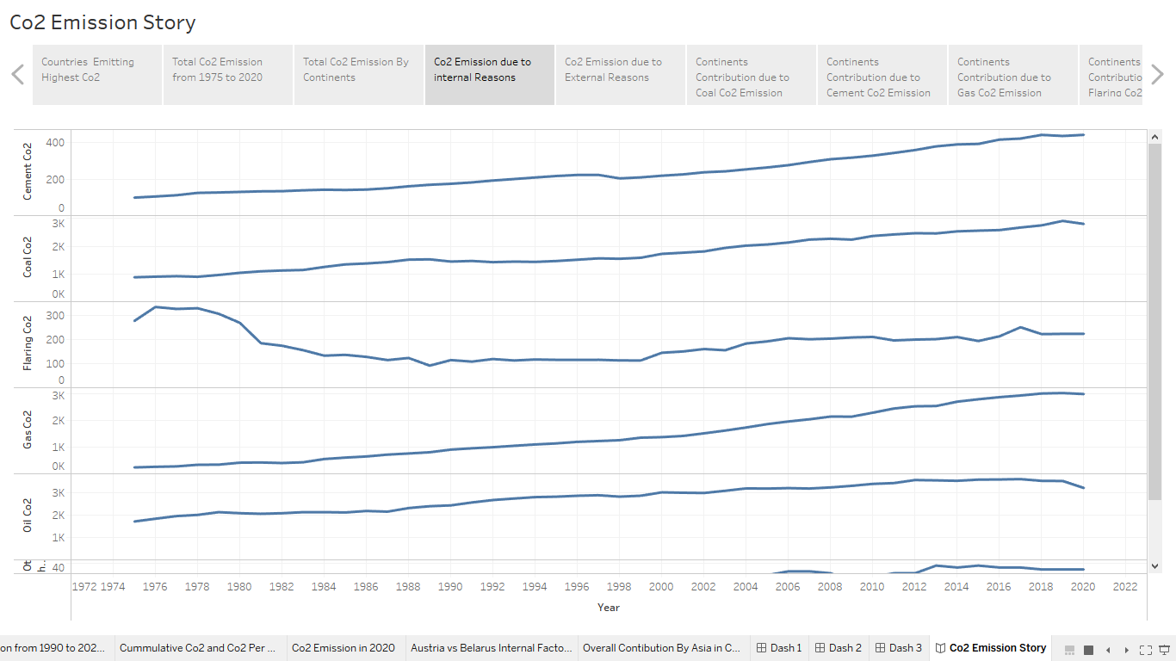



**3.5 Web integration**

Publishing helps us to track and monitor key performance metrics, to communicate results and progress. help a publisher stay informed, make better decisions, and communicate their performance to others.

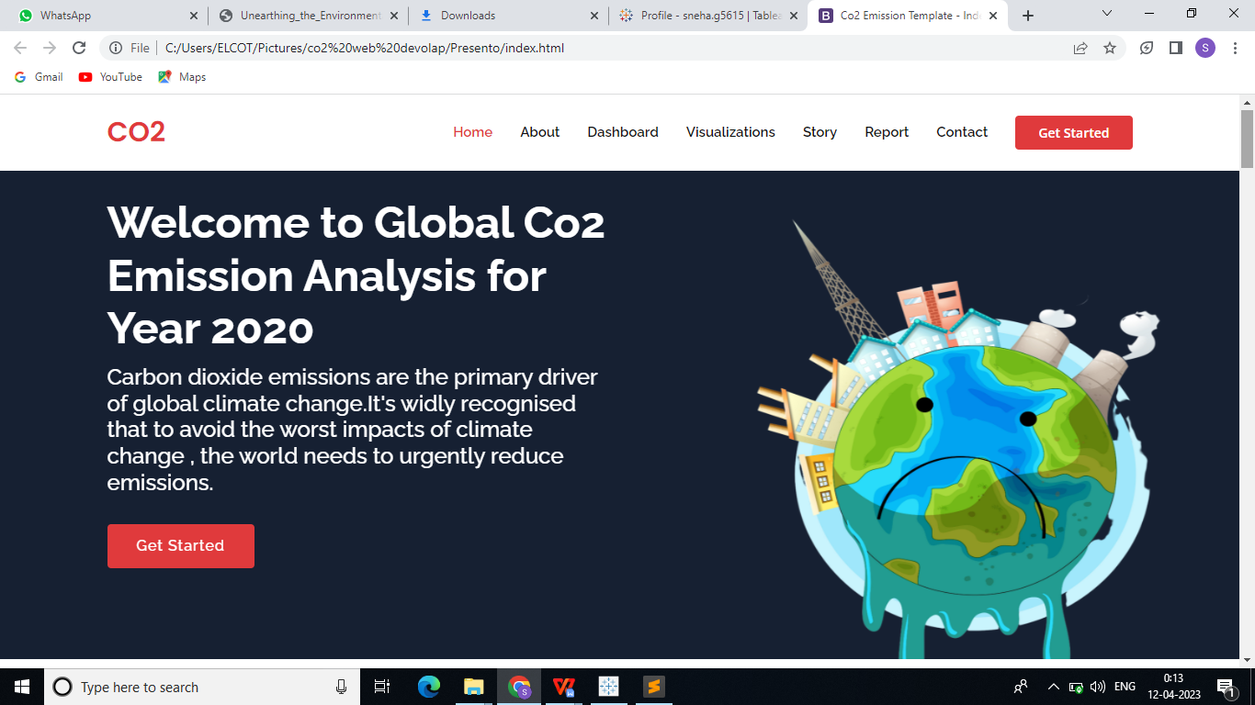

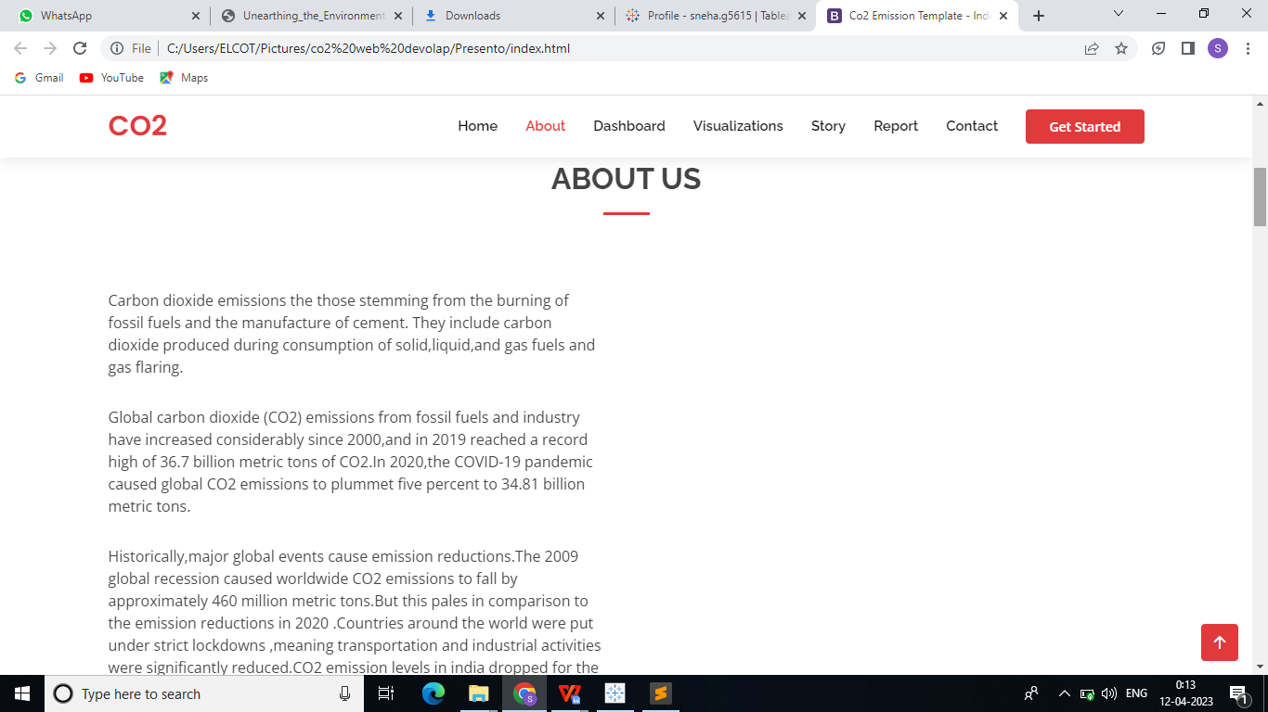

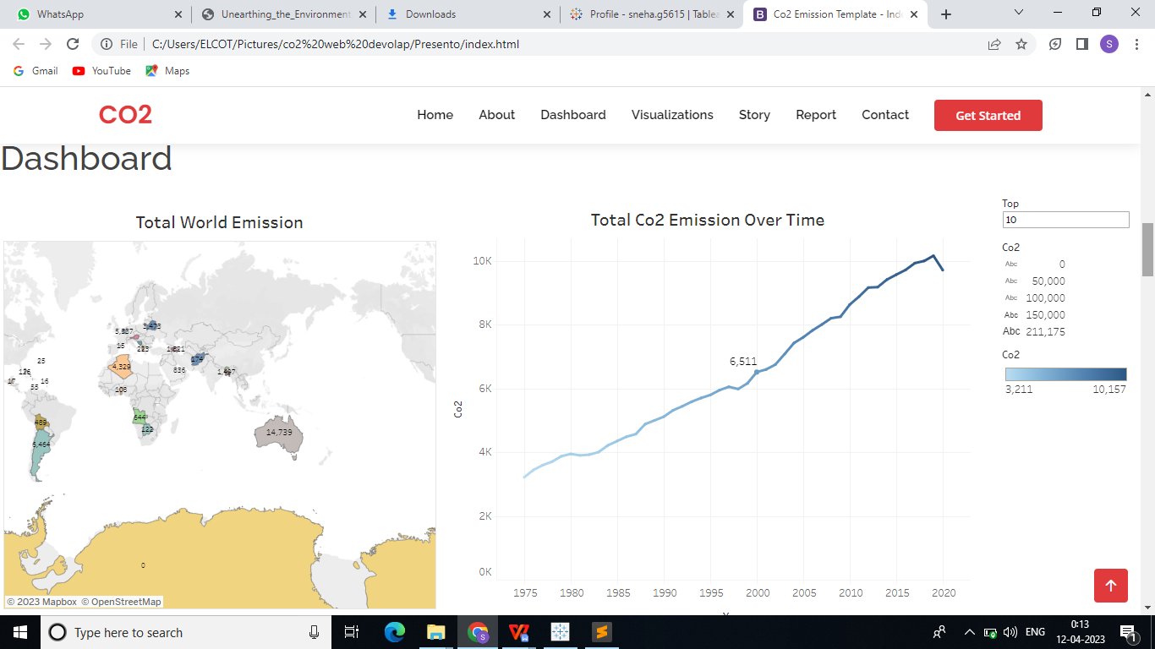

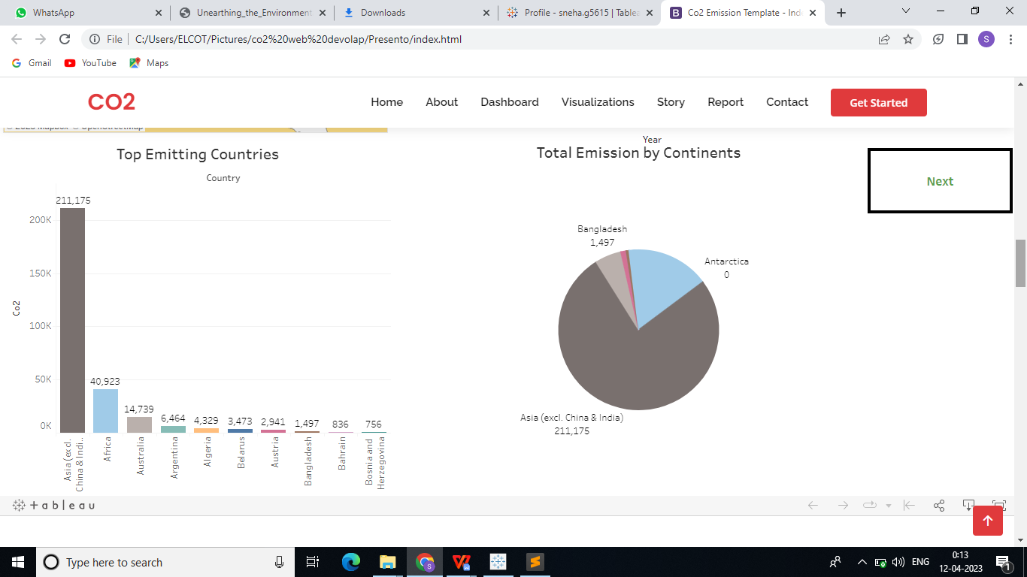

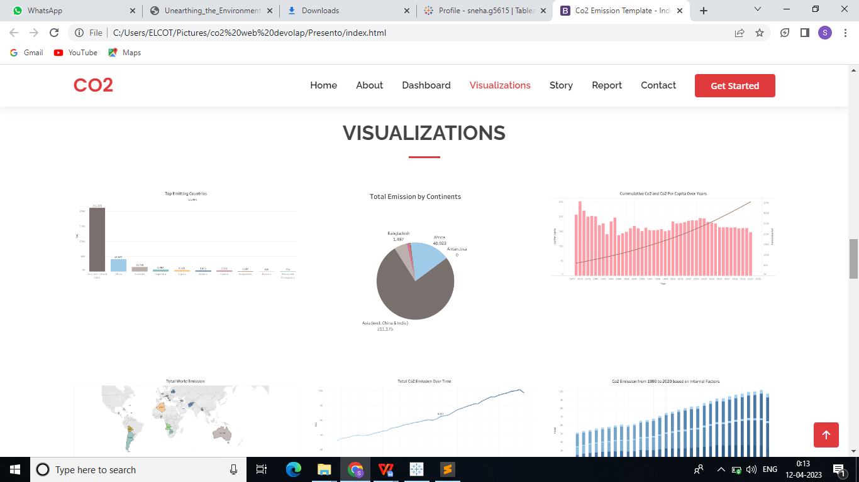

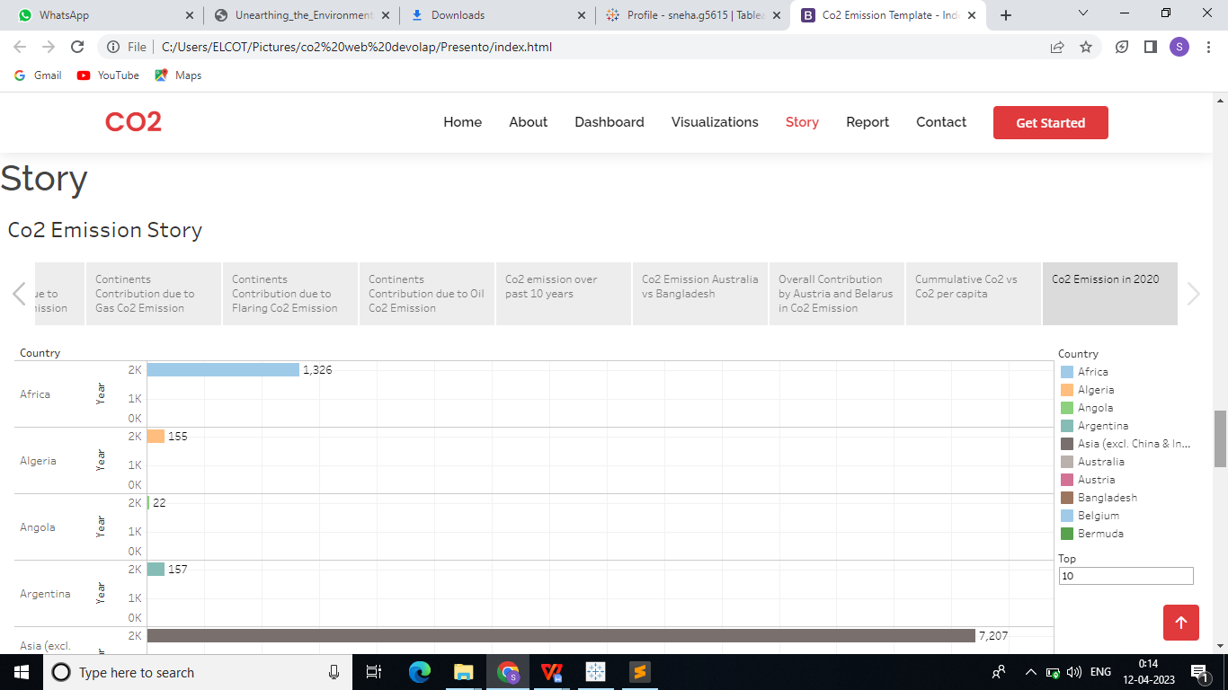

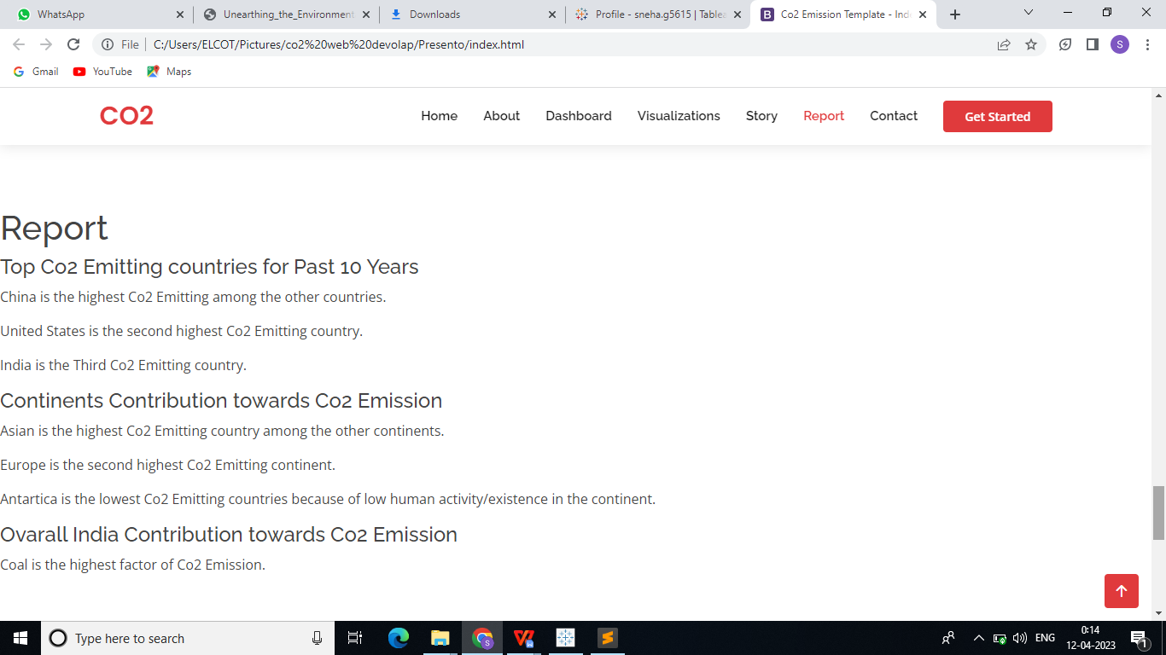

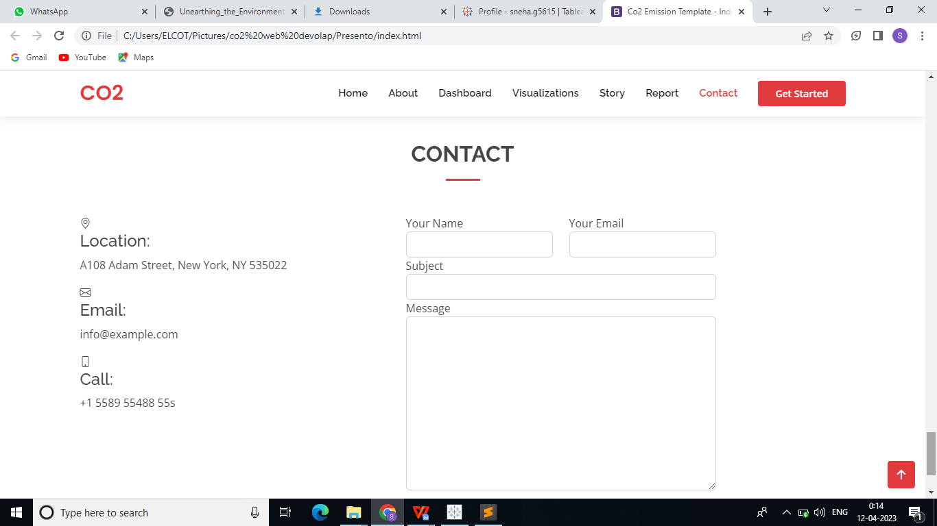

**4. ADVANTAGES & DISADVANTAGES**

## **4.1 Advantages of Carbon:**

Carbon capture and storage is one of the most efficient methods of extracting carbon emissions permanently from the environment.

The numerous advantages of CCS include economic, social, and environmental, and a massive impact on a global and local scale.

Carbon capture can increase the power generated with carbon dioxide-based steam cycles. In this process, carbon dioxide is pressured through a supercritical fluid, which could transfer heat more effectively and require less energy to compress steam.

Geologically stored carbon dioxide might be utilized to retrieve geothermal heat from the area injected which results in the generation of sustainable geothermal energy.

arbon dioxide captured with carbon capture can also be utilized in the manufacturing of polymers and chemicals such as polyurethanes.

The captured carbon dioxide is incorporated into concrete to reinforce it and increase the durability of the infrastructure. The carbon capture operations create employment for skilled engineers and technicians who need to operate them.

## **4.2 Disadvantages of Carbon :**

Carbon capture reduces the carbon released in the atmosphere and therefore, it is recognized as one of the solutions to help address climate change and global warming. Despite this, carbon capture and storage (CCS) does not come without some disadvantages.

The methods and CCS technologies that are necessary for carbon capture have some cost implications attached to them. Therefore, it can be very costly for power plants to generate electricity through fossil fuels. There are several concerns with respect to the safety of the storage of carbon dioxide in huge volumes at a single location due to the possibility of leakages, which can lead to environmental contamination if not handled correctly.

The possibility of leakages could also be a result of natural disasters such as earthquakes or can be a result of human-induced incidents such as damage as a result of wars that can damage underground storage reservoirs.

Many critics have questioned the cost efficiency of basalt formation storage. For this option, 25 tons of water will be required for each ton of carbon dioxide to be buried. There is a possibility that volcanic rock microbes can also digest the carbonates and hence produce methane gas which can be another problem.

Another disadvantage of carbon capture storage is that it is not adequate to successfully deal with climate change. The emissions that come from heat and power generation as a result of using fossil fuels only account for about 25% of the total greenhouse gas (GHG) emission, while 60% of all greenhouse gas emissions come from transportation, agriculture, and other related industrial activities. These emissions are currently not being captured by carbon capture and storage.

1. **APPLICATIONS:**
   1. **Uses of Carbon Dioxide:**

Carbon dioxide is used as a refrigerant, in fire extinguishers, to blow coal, foam rubber and plastics, inflate life rafts and life jackets, blast coal, promote plant growth in greenhouses, immobilise animals before slaughter, and in carbonated drinks. In the presence of sunlight, plants use it in the process of photosynthesis to create their own sustenance. Due to the gas' non-combustible nature, it is also used in fire extinguishers. Dry ice, which is used as a refrigerant, is made with carbon dioxide.

## **Uses of Carbon Dioxide in Everyday Life:**

Your body is built to control breathing by using carbon dioxide levels. You yawn and try to breathe more to try to expel the excess CO2 if your CO2 levels are too high. It's possible to forget to breathe if your CO2 levels are too low. Unconsciousness is a real possibility, and it may ultimately result in death.

Cement production, deforestation, the burning of fossil fuels like coal, oil, and natural gas (with CO2 emissions as a byproduct), transportation, industrial sources, chemical production, petroleum production, and agricultural practices are all examples of uses for carbon dioxide. It is also used to carbonate sodas, as an alternative to water in fire extinguishers, and to cool large (industrial size) refrigeration systems.

* **10 Uses of Carbon Dioxide:**
* Using both carbon and oxygen to create carbohydrates, plants use a process known as photosynthesis to convert carbon dioxide to oxygen.
* Another refrigerant utilised is carbon dioxide.
* It is used as a fire extinguisher.
* It is applied to encourage plant growth in greenhouses.
* Soft drinks, beer, and other carbonated beverages use it to add fizz.
* In large-scale refrigeration, a lot of dry ice is required for which solid carbon dioxide is employed.
* It is a component of medicinal gases since it encourages exhalation.
* The finest illustration of how carbon dioxide is used in daily life is when baking powder or yeast releases carbon dioxide to cause cake batter to rise.
* About 18% of the human body is made up of carbon dioxide.
* For the creation of inks and paints, amorphous carbon is employed.
* In your pencils, the lead is made of graphite.

1. **CONCLUSION**

Carbon dioxide is one of the major causes of climate change. There are several harmful effects of carbon dioxide on humans, animals, and plants. Reducing human activities that release carbon dioxide into the atmosphere will reduce the effects of global warming. Global warming is a major concern for the coming years. The release of carbon dioxide from human activities, deforestation, land-use changes and from use of fossil fuels is changing the face of our planet. Carbon dioxide is one of the greenhouse gases that contribute to global warming. It accounts for about 80% of total U.S. greenhouse gas (GHG) emissions, which makes it a very important target when considering potential GHG mitigation strategies. Carbon dioxide has been increasing in the Earth's atmosphere since the Industrial Revolution and is now at its highest level in at least 800,000 years.

**7.FUTURE SCOPE**

* The transit to energy sources that generate minimal or no greenhouse gases must be made. However, we should address the ever-increasing carbon emission industries.
* Sequestered carbon can become a vital instrument of global climate strategy if the carbon capture sectors continue to innovate and expand. Carbon capture technologies should be developed and scaled up to make them commercially feasible.
* CO2 can also **replace fossil fuels as a raw material in chemicals and polymers**. Less energy-intensive pathways include reacting CO2 with minerals or waste streams, such as iron slag, to form carbonates for building materials. The future market potential for CO2-derived products and services is difficult to assess.
* What does the future of our carbon dioxide and greenhouse gas emissions look like. In the visualization we show a range of potential future scenarios of global greenhouse gas emissions (measured in gigatonnes of carbon dioxide equivalents), based on data from [Climate Action Tracker](https://climateactiontracker.org/global/temperatures/" \t "https://ourworldindata.org/_blank).[1](https://ourworldindata.org/future-emissions" \l "note-1) Here, five scenarios are shown:

****No climate policies****:

projected future emissions if no climate policies were implemented; this would result in an estimated 4.1 to 4.8°C warming by 2100 (relative to pre-industrial temperatures);

****Current climate policies****:

projected warming of 2.8 to 3.2°C by 2100 based on current implemented climate policies;

****National pledges****:

if all countries achieve their current targets/pledges set within the Paris climate agreement, it’s estimated average warming by 2100 will be 2.5 to 2.8°C. This will go well beyond the overall target of the Paris Agreement to keep warming “well below 2°C”.

****2°C consistent****:

there are a range of emissions pathways that would be compatible with limiting average warming to 2°C by 2100. This would require a significant increase in ambition of the current pledges within the Paris Agreement.

****1.5°C consistent****:

there are a range of emissions pathways that would be compatible with limiting average warming to 1.5°C by 2100. However, all would require a very urgent and rapid reduction in global greenhouse gas emissions.

1. **APPENDIX**

**Source code for HTML**

<!DOCTYPE html>

<html lang="en">

<head>

<meta charset="utf-8">

<meta content="width=device-width, initial-scale=1.0" name="viewport">

<title>Co2 Emission Template - Index</title>

<meta content="" name="description">

<meta content="" name="keywords">

<!-- Favicons -->

<link href="assets/img/favicon.png" rel="icon">

<link href="assets/img/apple-touch-icon.png" rel="apple-touch-icon">

<!-- Google Fonts -->

<link href="https://fonts.googleapis.com/css?family=Open+Sans:300,300i,400,400i,600,600i,700,700i|Raleway:300,300i,400,400i,500,500i,600,600i,700,700i|Poppins:300,300i,400,400i,500,500i,600,600i,700,700i" rel="stylesheet">

<!-- Vendor CSS Files -->

<link href="assets/vendor/aos/aos.css" rel="stylesheet">

<link href="assets/vendor/bootstrap/css/bootstrap.min.css" rel="stylesheet">

<link href="assets/vendor/bootstrap-icons/bootstrap-icons.css" rel="stylesheet">

<link href="assets/vendor/boxicons/css/boxicons.min.css" rel="stylesheet">

<link href="assets/vendor/glightbox/css/glightbox.min.css" rel="stylesheet">

<link href="assets/vendor/remixicon/remixicon.css" rel="stylesheet">

<link href="assets/vendor/swiper/swiper-bundle.min.css" rel="stylesheet">

<!-- Template Main CSS File -->

<link href="assets/css/style.css" rel="stylesheet">

<!-- =======================================================

* Template Name: Presento

* Updated: Mar 10 2023 with Bootstrap v5.2.3

* Template URL: https://bootstrapmade.com/presento-bootstrap-corporate-template/

* Author: BootstrapMade.com

* License: https://bootstrapmade.com/license/

======================================================== -->

</head>

<body>

<!-- ======= Header ======= -->

<header id="header" class="fixed-top d-flex align-items-center">

<div class="container d-flex align-items-center">

<h1 class="logo me-auto"><a href="index.html"><span>CO2</span></a></h1>

<!-- Uncomment below if you prefer to use an image logo -->

<!-- <a href="index.html" class="logo me-auto"><img src="assets/img/logo.png" alt=""></a>-->

<nav id="navbar" class="navbar order-last order-lg-0">

<ul>

<li><a class="nav-link scrollto active" href="#hero">Home</a></li>

<li><a class="nav-link scrollto" href="#about">About</a></li>

<li><a class="nav-link scrollto" href="#dashboard">Dashboard</a></li>

<li><a class="nav-link scrollto " href="#portfolio">Visualizations</a></li>

<li><a class="nav-link scrollto" href="#story">Story</a></li>

<li><a class="nav-link scrollto" href="#report">Report</a></li>

<li><a class="nav-link scrollto" href="#contact">Contact</a></li>

</ul>

<i class="bi bi-list mobile-nav-toggle"></i>

</nav><!-- .navbar -->

<a href="#about" class="get-started-btn scrollto">Get Started</a>

</div>

</header><!-- End Header -->

<!-- ======= Hero Section ======= -->

<section id="hero" class="d-flex align-items-center">

<div class="container" data-aos="zoom-out" data-aos-delay="100">

<div class="row">

<div class="col-xl-6">

<img src="assets/img/earth.png" class="pic">

<h1>Welcome to Global Co2 Emission Analysis for Year 2020</h1>

<h2>Carbon dioxide emissions are the primary driver of global climate change.It's widly recognised that to avoid the worst impacts of climate change , the world needs to urgently reduce emissions.</h2>

<a href="#about" class="btn-get-started scrollto">Get Started</a>

</div>

</div>

</div>

</section><!-- End Hero -->

<main id="main">

<!-- ======= About Section ======= -->

<section id="about" class="about">

<div class="container" data-aos="fade-up">

<div class="section-title">

<h2>About Us</h2>

</div>

<div class="row content">

<div class=" ">

<p>Carbon dioxide emissions the those stemming from the burning of fossil fuels and the manufacture of cement. They include carbon dioxide produced during consumption of solid,liquid,and gas fuels and gas flaring.

</p>

<p> Global carbon dioxide (CO2) emissions from fossil fuels and industry have increased considerably since 2000,and in 2019 reached a record high of 36.7 billion metric tons of CO2.In 2020,the COVID-19 pandemic caused global CO2 emissions to plummet five percent to 34.81 billion metric tons.

<p>

<p> Historically,major global events cause emission reductions.The 2009 global recession caused worldwide CO2 emissions to fall by approximately 460 million metric tons.But this pales in comparison to the emission reductions in 2020 .Countries around the world were put under strict lockdowns ,meaning transportation and industrial activities were significantly reduced.CO2 emission levels in india dropped for the first time in four decades in the year ending March 2020.Global CO2 emissions per capita also experienced a substantial decline in 2020,falling to an average of 4.47 metric tons per person.<p>

</div>

</div>

</div>

</section>

<!-- End About Section -->

<!-- ======= Dashboard Section ======= -->

<section id="dashboaard">

<h1>Dashboard</h1>

<div><div class='tableauPlaceholder' id='viz1680870394028' style='position: relative'><noscript><a href='#'><img alt='Dash 1 ' src='https:&#47;&#47;public.tableau.com&#47;static&#47;images&#47;CO&#47;CO2DASHBOARD1&#47;Dash1&#47;1_rss.png' style='border: none' /></a></noscript><object class='tableauViz' style='display:none;'><param name='host_url' value='https%3A%2F%2Fpublic.tableau.com%2F' /> <param name='embed_code_version' value='3' /> <param name='site_root' value='' /><param name='name' value='CO2DASHBOARD1&#47;Dash1' /><param name='tabs' value='no' /><param name='toolbar' value='yes' /><param name='static_image' value='https:&#47;&#47;public.tableau.com&#47;static&#47;images&#47;CO&#47;CO2DASHBOARD1&#47;Dash1&#47;1.png' /> <param name='animate_transition' value='yes' /><param name='display_static_image' value='yes' /><param name='display_spinner' value='yes' /><param name='display_overlay' value='yes' /><param name='display_count' value='yes' /><param name='language' value='en-US' /></object></div> <script type='text/javascript'> var divElement = document.getElementById('viz1680870394028'); var vizElement = divElement.getElementsByTagName('object')[0]; if ( divElement.offsetWidth > 800 ) { vizElement.style.width='100%';vizElement.style.height=(divElement.offsetWidth*0.75)+'px';} else if ( divElement.offsetWidth > 500 ) { vizElement.style.width='100%';vizElement.style.height=(divElement.offsetWidth*0.75)+'px';} else { vizElement.style.width='100%';vizElement.style.height='1477px';} var scriptElement = document.createElement('script'); scriptElement.src = 'https://public.tableau.com/javascripts/api/viz_v1.js'; vizElement.parentNode.insertBefore(scriptElement, vizElement); </script>

</div>

</div>

</section>

<!-End Dashboard Section -->

<!-- ======= Visualization Section ======= -->

<section id="portfolio" class="portfolio">

<div class="container" data-aos="fade-up">

<div class="section-title">

<h2>VISUALIZATIONS</h2>

</div>

<div class="row portfolio-container" data-aos="fade-up" data-aos-delay="200">

<div class="col-lg-4 col-md-6 portfolio-item filter-app">

<div class="portfolio-wrap">

<img src="assets/img/VISUALIZATIONS PICS/SHEET 1.png" class="img-fluid" alt="">

</div>

</div>

<div class="col-lg-4 col-md-6 portfolio-item filter-web">

<div class="portfolio-wrap">

<img src="assets/img/VISUALIZATIONS PICS/SHEET 2.png" class="img-fluid" alt="">

</div>

</div>

<div class="col-lg-4 col-md-6 portfolio-item filter-app">

<div class="portfolio-wrap">

<img src="assets/img/VISUALIZATIONS PICS/SHEET 3.png" class="img-fluid" alt="">

</div>

</div>

<div class="col-lg-4 col-md-6 portfolio-item filter-card">

<div class="portfolio-wrap">

<img src="assets/img/VISUALIZATIONS PICS/SHEET 4.png" class="img-fluid" alt="">

</div>

</div>

<div class="col-lg-4 col-md-6 portfolio-item filter-web">

<div class="portfolio-wrap">

<img src="assets/img/VISUALIZATIONS PICS/SHEET 5.png" class="img-fluid" alt="">

</div>

</div>

<div class="col-lg-4 col-md-6 portfolio-item filter-app">

<div class="portfolio-wrap">

<img src="assets/img/VISUALIZATIONS PICS/SHEET 6.png" class="img-fluid" alt="">

</div>

</div>

</div>

</div>

</section><!-- End Visualization Section -->

<!-- ======= Story Section =======-->

<section id="story">

<h1>Story</h1>

<div> <div class='tableauPlaceholder' id='viz1680869948476' style='position: relative'><noscript><a href='#'><img alt='Co2 Emission Story ' src='https:&#47;&#47;public.tableau.com&#47;static&#47;images&#47;CO&#47;CO2STORY&#47;Co2EmissionStory&#47;1_rss.png' style='border: none' /></a></noscript><object class='tableauViz' style='display:none;'><param name='host_url' value='https%3A%2F%2Fpublic.tableau.com%2F' /> <param name='embed_code_version' value='3' /> <param name='site_root' value='' /><param name='name' value='CO2STORY&#47;Co2EmissionStory' /><param name='tabs' value='no' /><param name='toolbar' value='yes' /><param name='static_image' value='https:&#47;&#47;public.tableau.com&#47;static&#47;images&#47;CO&#47;CO2STORY&#47;Co2EmissionStory&#47;1.png' /> <param name='animate_transition' value='yes' /><param name='display_static_image' value='yes' /><param name='display_spinner' value='yes' /><param name='display_overlay' value='yes' /><param name='display_count' value='yes' /><param name='language' value='en-US' /></object></div> <script type='text/javascript'> var divElement = document.getElementById('viz1680869948476'); var vizElement = divElement.getElementsByTagName('object')[0]; vizElement.style.width='100%';vizElement.style.height=(divElement.offsetWidth*0.75)+'px'; var scriptElement = document.createElement('script'); scriptElement.src = 'https://public.tableau.com/javascripts/api/viz_v1.js'; vizElement.parentNode.insertBefore(scriptElement, vizElement); </script>

</div>

</div>

</section>

<!-End Story Section -->

<!-- ======= Report Section =======-->

<section id="report">

<h1>Report</h1>

<div class="content">

<h4>Top Co2 Emitting countries for Past 10 Years</h4>

<p>China is the highest Co2 Emitting among the other countries.</p>

<p>United States is the second highest Co2 Emitting country.</p>

<p>India is the Third Co2 Emitting country.</p>

<h4>Continents Contribution towards Co2 Emission</h4>

<p>Asian is the highest Co2 Emitting country among the other continents.</p>

<p>Europe is the second highest Co2 Emitting continent.</p>

<p>Antartica is the lowest Co2 Emitting countries because of low human activity/existence in the continent.</p>

<h4>Ovarall India Contribution towards Co2 Emission</h4>

<p>Coal is the highest factor of Co2 Emission.</p>

</div>

</section> <!--End Report Section -->

</main><!-- End #main -->

<!-- Contact Section -->

<section id="contact" class="contact">

<div class="container" data-aos="fade-up">

<div class="section-title">

<h2>Contact</h2>

</div>

<div class="row">

<div class="col-lg-5 d-flex align-items-stretch">

<div class="info">

<div class="address">

<i class="bi bi-geo-alt"></i>

<h4>Location:</h4>

<p>A108 Adam Street, New York, NY 535022</p>

</div>

<div class="email">

<i class="bi bi-envelope"></i>

<h4>Email:</h4>

<p>info@example.com</p>

</div>

<div class="phone">

<i class="bi bi-phone"></i>

<h4>Call:</h4>

<p>+1 5589 55488 55s</p>

</div>

</div>

</div>

<div class="col-lg-7 mt-5 mt-lg-0 d-flex align-items-stretch">

<form action="forms/contact.php" method="post" role="form" class="php-email-form">

<div class="row">

<div class="form-group col-md-6">

<label for="name">Your Name</label>

<input type="text" name="name" class="form-control" id="name" required>

</div>

<div class="form-group col-md-6">

<label for="name">Your Email</label>

<input type="email" class="form-control" name="email" id="email" required>

</div>

</div>

<div class="form-group">

<label for="name">Subject</label>

<input type="text" class="form-control" name="subject" id="subject" required>

</div>

<div class="form-group">

<label for="name">Message</label>

<textarea class="form-control" name="message" rows="10" required></textarea>

</div>

<div class="my-3">

<div class="loading">Loading</div>

<div class="error-message"></div>

<div class="sent-message">Your message has been sent. Thank you!</div>

</div>

<div class="text-center"><button type="submit">Send Message</button></div>

</form>

</div>

</div>

</div>

</section>

<!--End Contact Section-->

<a href="#" class="back-to-top d-flex align-items-center justify-content-center"><i class="bi bi-arrow-up-short"></i></a>

<!-- Vendor JS Files -->

<script src="assets/vendor/purecounter/purecounter_vanilla.js"></script>

<script src="assets/vendor/aos/aos.js"></script>

<script src="assets/vendor/bootstrap/js/bootstrap.bundle.min.js"></script>

<script src="assets/vendor/glightbox/js/glightbox.min.js"></script>

<script src="assets/vendor/isotope-layout/isotope.pkgd.min.js"></script>

<script src="assets/vendor/swiper/swiper-bundle.min.js"></script>

<script src="assets/vendor/php-email-form/validate.js"></script>

<!-- Template Main JS File -->

<script src="assets/js/main.js"></script>

</body>

</html>

**Source code for CSS**

body {

font-family: "Open Sans", sans-serif;

color: #444444;

}

a {

color: #e03a3c;

text-decoration: none;

}

a:hover {

color: #e76668;

text-decoration: none;

}

h1,

h2,

h3,

h4,

h5,

h6 {

font-family: "Raleway", sans-serif;

}

/*--------------------------------------------------------------

# Back to top button

--------------------------------------------------------------*/

.back-to-top {

position: fixed;

visibility: hidden;

opacity: 0;

right: 15px;

bottom: 15px;

z-index: 996;

background: #e03a3c;

width: 40px;

height: 40px;

border-radius: 4px;

transition: all 0.4s;

}

.back-to-top i {

font-size: 28px;

color: #fff;

line-height: 0;

}

.back-to-top:hover {

background: #e65d5f;

color: #fff;

}

.back-to-top.active {

visibility: visible;

opacity: 1;

}

/*--------------------------------------------------------------

# Disable aos animation delay on mobile devices

--------------------------------------------------------------*/

@media screen and (max-width: 768px) {

[data-aos-delay] {

transition-delay: 0 !important;

}

}

/*--------------------------------------------------------------

# Header

--------------------------------------------------------------*/

#header {

background: #fff;

transition: all 0.5s;

z-index: 997;

padding: 20px 0;

}

#header.header-scrolled {

padding: 12px 0;

box-shadow: 0px 2px 15px rgba(0, 0, 0, 0.1);

}

#header .logo {

font-size: 30px;

margin: 0;

padding: 0;

font-weight: 600;

font-family: "Poppins", sans-serif;

}

#header .logo a {

color: #111111;

}

#header .logo a span {

color: #e03a3c;

}

#header .logo img {

max-height: 40px;

}

/*--------------------------------------------------------------

# Get Startet Button

--------------------------------------------------------------*/

.get-started-btn {

margin-left: 30px;

background: #e03a3c;

color: #fff;

border-radius: 4px;

padding: 8px 25px;

white-space: nowrap;

transition: 0.3s;

font-size: 14px;

font-weight: 600;

display: inline-block;

}

.get-started-btn:hover {

background: #111111;

color: #fff;

}

@media (max-width: 992px) {

.get-started-btn {

margin: 0 15px 0 0;

padding: 6px 18px;

}

}

/*--------------------------------------------------------------

# Navigation Menu

--------------------------------------------------------------*/

/**

* Desktop Navigation

*/

.navbar {

padding: 0;

}

.navbar ul {

margin: 0;

padding: 0;

display: flex;

list-style: none;

align-items: center;

}

.navbar li {

position: relative;

}

.navbar a,

.navbar a:focus {

display: flex;

align-items: center;

justify-content: space-between;

padding: 10px 0 10px 30px;

font-family: "Raleway", sans-serif;

font-size: 15px;

font-weight: 600;

color: #111111;

white-space: nowrap;

transition: 0.3s;

}

.navbar a i,

.navbar a:focus i {

font-size: 12px;

line-height: 0;

margin-left: 5px;

}

.navbar a:hover,

.navbar .active,

.navbar .active:focus,

.navbar li:hover>a {

color: #e03a3c;

}

.navbar .dropdown ul {

display: block;

position: absolute;

left: 30px;

top: calc(100% + 30px);

margin: 0;

padding: 10px 0;

z-index: 99;

opacity: 0;

visibility: hidden;

background: #fff;

box-shadow: 0px 0px 30px rgba(127, 137, 161, 0.25);

transition: 0.3s;

}

.navbar .dropdown ul li {

min-width: 200px;

}

.navbar .dropdown ul a {

padding: 10px 20px;

font-size: 14px;

}

.navbar .dropdown ul a i {

font-size: 12px;

}

.navbar .dropdown ul a:hover,

.navbar .dropdown ul .active:hover,

.navbar .dropdown ul li:hover>a {

color: #e03a3c;

}

.navbar .dropdown:hover>ul {

opacity: 1;

top: 100%;

visibility: visible;

}

.navbar .dropdown .dropdown ul {

top: 0;

left: calc(100% - 30px);

visibility: hidden;

}

.navbar .dropdown .dropdown:hover>ul {

opacity: 1;

top: 0;

left: 100%;

visibility: visible;

}

@media (max-width: 1366px) {

.navbar .dropdown .dropdown ul {

left: -90%;

}

.navbar .dropdown .dropdown:hover>ul {

left: -100%;

}

}

/**

* Mobile Navigation

*/

.mobile-nav-toggle {

color: #111111;

font-size: 28px;

cursor: pointer;

display: none;

line-height: 0;

transition: 0.5s;

}

.mobile-nav-toggle.bi-x {

color: #fff;

}

@media (max-width: 991px) {

.mobile-nav-toggle {

display: block;

}

.navbar ul {

display: none;

}

}

.navbar-mobile {

position: fixed;

overflow: hidden;

top: 0;

right: 0;

left: 0;

bottom: 0;

background: rgba(0, 0, 0, 0.9);

transition: 0.3s;

z-index: 999;

}

.navbar-mobile .mobile-nav-toggle {

position: absolute;

top: 15px;

right: 15px;

}

.navbar-mobile ul {

display: block;

position: absolute;

top: 55px;

right: 15px;

bottom: 15px;

left: 15px;

padding: 10px 0;

background-color: #fff;

overflow-y: auto;

transition: 0.3s;

}

.navbar-mobile a,

.navbar-mobile a:focus {

padding: 10px 20px;

font-size: 15px;

color: #111111;

}

.navbar-mobile a:hover,

.navbar-mobile .active,

.navbar-mobile li:hover>a {

color: #e03a3c;

}

.navbar-mobile .getstarted,

.navbar-mobile .getstarted:focus {

margin: 15px;

}

.navbar-mobile .dropdown ul {

position: static;

display: none;

margin: 10px 20px;

padding: 10px 0;

z-index: 99;

opacity: 1;

visibility: visible;

background: #fff;

box-shadow: 0px 0px 30px rgba(127, 137, 161, 0.25);

}

.navbar-mobile .dropdown ul li {

min-width: 200px;

}

.navbar-mobile .dropdown ul a {

padding: 10px 20px;

}

.navbar-mobile .dropdown ul a i {

font-size: 12px;

}

.navbar-mobile .dropdown ul a:hover,

.navbar-mobile .dropdown ul .active:hover,

.navbar-mobile .dropdown ul li:hover>a {

color: #e03a3c;

}

.navbar-mobile .dropdown>.dropdown-active {

display: block;

}

/*--------------------------------------------------------------

# Hero Section

--------------------------------------------------------------*/

#hero {

width: 100%;

height: 100vh;

background: #37517e;

background-size: cover;

position: relative;

padding-top: 82px;

}

.pic{

position: absolute;

height: 560px;

width: 500px;

margin-left: 700px;

padding-top:0px ;

}

#hero .pic{

animation: up-down 2s ease-in-out infinite alternate-reverse both;

}

@keyframes up-down {

0% {

transform: translateY(10px);

}

100% {

transform: translateY(-10px);

}

}

#hero:before {

content: "";

background: rgba(0, 0, 0, 0.6);

position: absolute;

bottom: 0;

top: 0;

left: 0;

right: 0;

}

#hero h1 {

margin: 0;

font-size: 48px;

font-weight: 700;

color: #fff;

}

#hero h2 {

color: #fff;

margin: 10px 0 0 0;

font-size: 24px;

}

#hero .btn-get-started {

font-family: "Raleway", sans-serif;

font-weight: 500;

font-size: 16px;

letter-spacing: 1px;

display: inline-block;

padding: 10px 30px;

border-radius: 4px;

transition: 0.5s;

margin-top: 30px;

color: #fff;

background: #e03a3c;

border: 2px solid #e03a3c;

}

#hero .btn-get-started:hover {

background: transparent;

border-color: #fff;

}

@media (max-width: 768px) {

#hero {

text-align: center;

padding-top: 58px;

}

#hero h1 {

font-size: 28px;

}

#hero h2 {

font-size: 18px;

line-height: 24px;

}

}

@media (max-height: 500px) {

#hero {

height: 120vh;

}

}

/*--------------------------------------------------------------

# Sections General

--------------------------------------------------------------*/

section {

padding: 60px 0;

overflow: hidden;

position: relative;

}

.section-title {

text-align: center;

padding-bottom: 30px;

position: relative;

}

.section-title h2 {

font-size: 32px;

font-weight: bold;

text-transform: uppercase;

margin-bottom: 20px;

padding-bottom: 20px;

position: relative;

}

.section-title h2::after {

content: "";

position: absolute;

display: block;

width: 50px;

height: 3px;

background: #e03a3c;

bottom: 0;

left: calc(50% - 25px);

}

.section-title p {

margin-bottom: 0;

}

.section-bg {

padding: 120px 0;

color: #fff;

}

.section-bg:before {

content: "";

background: #1b1b1b;

position: absolute;

bottom: 60px;

top: 60px;

left: 0;

right: 0;

transform: skewY(-3deg);

}

/*--------------------------------------------------------------

# Report Section

--------------------------------------------------------------*/

.content h4 {

margin-right: 10px;

margin-right: 550px;

}

.content p {

margin-right:550px;

}

/*--------------------------------------------------------------

# Breadcrumbs

--------------------------------------------------------------*/

.breadcrumbs {

padding: 15px 0;

background: #2b2b2b;

min-height: 40px;

margin-top: 82px;

color: #fff;

}

.breadcrumbs h2 {

font-size: 28px;

font-weight: 500;

}

.breadcrumbs ol {

display: flex;

flex-wrap: wrap;

list-style: none;

padding: 0 0 10px 0;

margin: 0;

font-size: 14px;

}

.breadcrumbs ol a {

color: #aaaaaa;

}

.breadcrumbs ol a:hover {

color: #fff;

transition: 0.3s;

}

.breadcrumbs ol li+li {

padding-left: 10px;

}

.breadcrumbs ol li+li::before {

display: inline-block;

padding-right: 10px;

color: #e03a3c;

content: "/";

}

/*--------------------------------------------------------------

# Clients

--------------------------------------------------------------*/

.clients .swiper-pagination {

margin-top: 20px;

position: relative;

}

.clients .swiper-pagination .swiper-pagination-bullet {

width: 12px;

height: 12px;

background-color: #fff;

opacity: 1;

border: 1px solid #e03a3c;

}

.clients .swiper-pagination .swiper-pagination-bullet-active {

background-color: #e03a3c;

}

.clients .swiper-slide img {

opacity: 0.5;

transition: 0.3s;

filter: grayscale(100);

}

.clients .swiper-slide img:hover {

opacity: 1;

filter: none;

}

/*--------------------------------------------------------------

# About

--------------------------------------------------------------*/

.about .container {

position: relative;

z-index: 10;

}

.about .content {

padding: 30px 30px 30px 0;

}

.about .content h3 {

font-weight: 700;

font-size: 34px;

margin-bottom: 30px;

}

.about .content p {

margin-bottom: 30px;

}

.about .content .about-btn {

padding: 8px 30px 9px 30px;

color: #fff;

border-radius: 50px;

transition: 0.3s;

text-transform: uppercase;

font-weight: 600;

font-size: 13px;

display: inline-flex;

align-items: center;

border: 2px solid #e03a3c;

}

.about .content .about-btn i {

font-size: 16px;

padding-left: 5px;

}

.about .content .about-btn:hover {

background: #e35052;

background: #e03a3c;

}

.about .icon-boxes .icon-box {

margin-top: 30px;

}

.about .icon-boxes .icon-box i {

font-size: 40px;

color: #e03a3c;

margin-bottom: 10px;

}

.about .icon-boxes .icon-box h4 {

font-size: 20px;

font-weight: 700;

margin: 0 0 10px 0;

}

.about .icon-boxes .icon-box p {

font-size: 15px;

color: #848484;

}

@media (max-width: 1200px) {

.about .content {

padding-right: 0;

}

}

@media (max-width: 768px) {

.about {

text-align: center;

}

}

/*--------------------------------------------------------------

# Counts

--------------------------------------------------------------*/

.counts {

padding-top: 80px;

}

.counts .count-box {

padding: 30px 30px 25px 30px;

width: 100%;

position: relative;

text-align: center;

box-shadow: 0px 2px 35px rgba(0, 0, 0, 0.06);

border-radius: 4px;

}

.counts .count-box i {

position: absolute;

width: 54px;

height: 54px;

top: -27px;

left: 50%;

transform: translateX(-50%);

font-size: 24px;

background: #fff;

color: #e03a3c;

border-radius: 50px;

border: 2px solid #fff;

box-shadow: 0px 2px 25px rgba(0, 0, 0, 0.1);

display: inline-flex;

align-items: center;

justify-content: center;

}

.counts .count-box span {

font-size: 36px;

display: block;

font-weight: 700;

color: #111111;

}

.counts .count-box p {

padding: 0;

margin: 0;

font-family: "Raleway", sans-serif;

font-size: 14px;

}

/*--------------------------------------------------------------

# Tabs

--------------------------------------------------------------*/

.tabs .nav-tabs {

border: 0;

}

.tabs .nav-link {

border: 1px solid #b9b9b9;

padding: 15px;

transition: 0.3s;

color: #111111;

border-radius: 0;

display: flex;

align-items: center;

justify-content: center;

cursor: pointer;

}

.tabs .nav-link i {

padding-right: 15px;

font-size: 48px;

}

.tabs .nav-link h4 {

font-size: 18px;

font-weight: 600;

margin: 0;

}

.tabs .nav-link:hover {

color: #e03a3c;

}

.tabs .nav-link.active {

background: #e03a3c;

color: #fff;

border-color: #e03a3c;

}

@media (max-width: 768px) {

.tabs .nav-link i {

padding: 0;

line-height: 1;

font-size: 36px;

}

}

@media (max-width: 575px) {

.tabs .nav-link {

padding: 15px;

}

.tabs .nav-link i {

font-size: 24px;

}

}

.tabs .tab-content {

margin-top: 30px;

}

.tabs .tab-pane h3 {

font-weight: 600;

font-size: 26px;

}

.tabs .tab-pane ul {

list-style: none;

padding: 0;

}

.tabs .tab-pane ul li {

padding-bottom: 10px;

}

.tabs .tab-pane ul i {

font-size: 20px;

padding-right: 4px;

color: #e03a3c;

}

.tabs .tab-pane p:last-child {

margin-bottom: 0;

}

/*--------------------------------------------------------------

# Services

--------------------------------------------------------------*/

.services .icon-box {

margin-bottom: 20px;

padding: 30px;

border-radius: 6px;

background: #252525;

transition: 0.3s;

}

.services .icon-box:hover {

background: #2b2b2b;

}

.services .icon-box i {

float: left;

color: #e03a3c;

font-size: 40px;

line-height: 0;

}

.services .icon-box h4 {

margin-left: 70px;

font-weight: 700;

margin-bottom: 15px;

font-size: 18px;

}

.services .icon-box h4 a {

color: #fff;

transition: 0.3s;

}

.services .icon-box h4 a:hover {

text-decoration: underline;

}

.services .icon-box .icon-box:hover h4 a {

color: #e03a3c;

}

.services .icon-box p {

margin-left: 70px;

line-height: 24px;

font-size: 14px;

}

/*--------------------------------------------------------------

# Portfolio

--------------------------------------------------------------*/

.portfolio .portfolio-item {

margin-bottom: 30px;

}

.portfolio #portfolio-flters {

padding: 0;

margin: 0 auto 20px auto;

list-style: none;

text-align: center;

}

.portfolio #portfolio-flters li {

cursor: pointer;

display: inline-block;

padding: 8px 15px 10px 15px;

font-size: 14px;

font-weight: 600;

line-height: 1;

text-transform: uppercase;

color: #444444;

margin-bottom: 5px;

transition: all 0.3s ease-in-out;

border-radius: 3px;

}

.portfolio #portfolio-flters li:hover,

.portfolio #portfolio-flters li.filter-active {

color: #fff;

background: #e03a3c;

}

.portfolio #portfolio-flters li:last-child {

margin-right: 0;

}

.portfolio .portfolio-wrap {

transition: 0.3s;

position: relative;

overflow: hidden;

z-index: 1;

background: rgba(17, 17, 17, 0.6);

}

.portfolio .portfolio-wrap::before {

content: "";

background: rgba(17, 17, 17, 0.6);

position: absolute;

left: 0;

right: 0;

top: 0;

bottom: 0;

transition: all ease-in-out 0.3s;

z-index: 2;

opacity: 0;

}

.portfolio .portfolio-wrap img {

transition: all ease-in-out 0.3s;

}

.portfolio .portfolio-wrap .portfolio-info {

opacity: 0;

position: absolute;

top: 0;

left: 0;

right: 0;

bottom: 0;

z-index: 3;

transition: all ease-in-out 0.3s;

display: flex;

flex-direction: column;

justify-content: flex-end;

align-items: flex-start;

padding: 20px;

}

.portfolio .portfolio-wrap .portfolio-info h4 {

font-size: 20px;

color: #fff;

font-weight: 600;

}

.portfolio .portfolio-wrap .portfolio-info p {

color: rgba(255, 255, 255, 0.7);

font-size: 14px;

text-transform: uppercase;

padding: 0;

margin: 0;

font-style: italic;

}

.portfolio .portfolio-wrap .portfolio-links {

text-align: center;

z-index: 4;

}

.portfolio .portfolio-wrap .portfolio-links a {

color: rgba(255, 255, 255, 0.4);

margin: 0 5px 0 0;

font-size: 28px;

display: inline-block;

transition: 0.3s;

}

.portfolio .portfolio-wrap .portfolio-links a:hover {

color: #fff;

}

.portfolio .portfolio-wrap:hover::before {

opacity: 1;

}

.portfolio .portfolio-wrap:hover img {

transform: scale(1.2);

}

.portfolio .portfolio-wrap:hover .portfolio-info {

opacity: 1;

}

/*--------------------------------------------------------------

# Portfolio Details

--------------------------------------------------------------*/

.portfolio-details {

padding-top: 40px;

}

.portfolio-details .portfolio-details-slider img {

width: 100%;

}

.portfolio-details .portfolio-details-slider .swiper-pagination {

margin-top: 20px;

position: relative;

}

.portfolio-details .portfolio-details-slider .swiper-pagination .swiper-pagination-bullet {

width: 12px;

height: 12px;

background-color: #fff;

opacity: 1;

border: 1px solid #e03a3c;

}

.portfolio-details .portfolio-details-slider .swiper-pagination .swiper-pagination-bullet-active {

background-color: #e03a3c;

}

.portfolio-details .portfolio-info {

padding: 30px;

box-shadow: 0px 0 30px rgba(17, 17, 17, 0.08);

}

.portfolio-details .portfolio-info h3 {

font-size: 22px;

font-weight: 700;

margin-bottom: 20px;

padding-bottom: 20px;

border-bottom: 1px solid #eee;

}

.portfolio-details .portfolio-info ul {

list-style: none;

padding: 0;

font-size: 15px;

}

.portfolio-details .portfolio-info ul li+li {

margin-top: 10px;

}

.portfolio-details .portfolio-description {

padding-top: 30px;

}

.portfolio-details .portfolio-description h2 {

font-size: 26px;

font-weight: 700;

margin-bottom: 20px;

}

.portfolio-details .portfolio-description p {

padding: 0;

}

/*--------------------------------------------------------------

# Testimonials

--------------------------------------------------------------*/

.testimonials .testimonials-carousel,

.testimonials .testimonials-slider {

overflow: hidden;

}

.testimonials .testimonial-item {

box-sizing: content-box;

padding: 30px;

margin: 30px 15px;

min-height: 200px;

box-shadow: 0px 2px 12px rgba(0, 0, 0, 0.08);

position: relative;

background: #fff;

border-radius: 15px;

}

.testimonials .testimonial-item .testimonial-img {

width: 90px;

border-radius: 10px;

border: 6px solid #fff;

float: left;

margin: 0 10px 0 0;

}

.testimonials .testimonial-item h3 {

font-size: 18px;

font-weight: bold;

margin: 25px 0 5px 0;

color: #111;

}

.testimonials .testimonial-item h4 {

font-size: 14px;

color: #999;

margin: 0;

}

.testimonials .testimonial-item .quote-icon-left,

.testimonials .testimonial-item .quote-icon-right {

color: #fceaea;

font-size: 26px;

}

.testimonials .testimonial-item .quote-icon-left {

display: inline-block;

left: -5px;

position: relative;

}

.testimonials .testimonial-item .quote-icon-right {

display: inline-block;

right: -5px;

position: relative;

top: 10px;

}

.testimonials .testimonial-item p {

font-style: italic;

margin: 30px auto 15px auto;

}

.testimonials .swiper-pagination {

margin-top: 20px;

position: relative;

}

.testimonials .swiper-pagination .swiper-pagination-bullet {

width: 12px;

height: 12px;

background-color: #fff;

opacity: 1;

border: 1px solid #e03a3c;

}

.testimonials .swiper-pagination .swiper-pagination-bullet-active {

background-color: #e03a3c;

}

/*--------------------------------------------------------------

# Pricing

--------------------------------------------------------------*/

.pricing .box {

padding: 20px;

background: #2b2b2b;

text-align: center;

border-radius: 8px;

position: relative;

overflow: hidden;

}

.pricing .box h3 {

font-weight: 400;

padding: 15px;

font-size: 18px;

text-transform: uppercase;

font-weight: 600;

}

.pricing .box h4 {

font-size: 42px;

font-weight: 500;

font-family: "Open Sans", sans-serif;

margin-bottom: 20px;

}

.pricing .box h4 sup {

font-size: 20px;

top: -15px;

left: -3px;

}

.pricing .box h4 span {

font-size: 16px;

font-weight: 300;

}

.pricing .box ul {

padding: 0;

list-style: none;

text-align: center;

line-height: 20px;

font-size: 14px;

}

.pricing .box ul li {

padding-bottom: 16px;

}

.pricing .box ul i {

color: #e03a3c;

font-size: 18px;

padding-right: 4px;

}

.pricing .box ul .na {

color: rgba(255, 255, 255, 0.5);

text-decoration: line-through;

}

.pricing .box .btn-wrap {

padding: 15px;

text-align: center;

}

.pricing .box .btn-buy {

display: inline-block;

padding: 10px 40px 12px 40px;

border-radius: 4px;

color: #fff;

transition: none;

font-size: 14px;

font-weight: 400;

font-family: "Raleway", sans-serif;

font-weight: 600;

transition: 0.3s;

border: 2px solid rgba(255, 255, 255, 0.3);

}

.pricing .box .btn-buy:hover {

border-color: #fff;

}

.pricing .featured {

background: #e03a3c;

}

/*--------------------------------------------------------------

# Frequently Asked Questions

--------------------------------------------------------------*/

.faq .faq-list {

padding: 0;

list-style: none;

}

.faq .faq-list li {

border-bottom: 1px solid #eee;

margin-bottom: 20px;

padding-bottom: 20px;

}

.faq .faq-list a {

display: block;

position: relative;

font-family: #e03a3c;

font-size: 18px;

line-height: 24px;

font-weight: 400;

padding-right: 25px;

cursor: pointer;

}

.faq .faq-list i {

font-size: 24px;

position: absolute;

right: 0;

top: 0;

}

.faq .faq-list p {

margin-bottom: 0;

padding: 10px 0 0 0;

}

.faq .faq-list .icon-show {

display: none;

}

.faq .faq-list a.collapsed {

color: #343a40;

}

.faq .faq-list a.collapsed:hover {

color: #e03a3c;

}

.faq .faq-list a.collapsed .icon-show {

display: inline-block;

}

.faq .faq-list a.collapsed .icon-close {

display: none;

}

/*--------------------------------------------------------------

# Team

--------------------------------------------------------------*/

.team .member {

margin-bottom: 20px;

overflow: hidden;

border-radius: 5px;

background: #fff;

}

.team .member .member-img {

position: relative;

overflow: hidden;

}

.team .member .social {

position: absolute;

left: 0;

bottom: 30px;

right: 0;

opacity: 0;

transition: ease-in-out 0.3s;

display: flex;

align-items: center;

justify-content: center;

}

.team .member .social a {

transition: color 0.3s;

color: #111111;

margin: 0 3px;

border-radius: 50px;

width: 36px;

height: 36px;

background: #e03a3c;

display: inline-flex;

align-items: center;

justify-content: center;

transition: ease-in-out 0.3s;

color: #fff;

}

.team .member .social a:hover {

background: #111111;

}

.team .member .social i {

font-size: 18px;

line-height: 0;

}

.team .member .member-info {

padding: 25px 15px;

}

.team .member .member-info h4 {

font-weight: 700;

margin-bottom: 5px;

font-size: 18px;

color: #111111;

}

.team .member .member-info span {

display: block;

font-size: 13px;

font-weight: 400;

color: #aaaaaa;

}

.team .member .member-info p {

font-style: italic;

font-size: 14px;

line-height: 26px;

color: #777777;

}

.team .member:hover .social {

opacity: 1;

bottom: 15px;

}

/*--------------------------------------------------------------

# Conclusion

--------------------------------------------------------------*/

/*#conclusion .content ul p {

display: block;

position: absolute;

left: 30px;

top: calc(100% + 30px);

margin: 0;

padding: 10px 0;

z-index: 99;

opacity: 0;

visibility: hidden;

background: #fff;

box-shadow: 0px 0px 30px rgba(127, 137, 161, 0.25);

transition: 0.3s;

}

.content ul a:hover,

.content ul .active:hover,

.dropdown ul li:hover>a {

color: #e03a3c;

}

#conclusion .content h3 {

font-weight: 700;

font-size: 34px;

margin-bottom: 30px;

}

#conclusion .content p {

margin-bottom: 30px;

*/

/*--------------------------------------------------------------

# Blog

--------------------------------------------------------------*/

.blog {

padding: 40px 0 20px 0;

}

.blog .entry {

padding: 30px;

margin-bottom: 60px;

box-shadow: 0 4px 16px rgba(0, 0, 0, 0.1);

}

.blog .entry .entry-img {

max-height: 440px;

margin: -30px -30px 20px -30px;

overflow: hidden;

}

.blog .entry .entry-title {

font-size: 28px;

font-weight: bold;

padding: 0;

margin: 0 0 20px 0;

}

.blog .entry .entry-title a {

color: #111111;

transition: 0.3s;

}

.blog .entry .entry-title a:hover {

color: #e03a3c;

}

.blog .entry .entry-meta {

margin-bottom: 15px;

color: #777777;

}

.blog .entry .entry-meta ul {

display: flex;

flex-wrap: wrap;

list-style: none;

align-items: center;

padding: 0;

margin: 0;

}

.blog .entry .entry-meta ul li+li {

padding-left: 20px;

}

.blog .entry .entry-meta i {

font-size: 16px;

margin-right: 8px;

line-height: 0;

}

.blog .entry .entry-meta a {

color: #777777;

font-size: 14px;

display: inline-block;

line-height: 1;

}

.blog .entry .entry-content p {

line-height: 24px;

}

.blog .entry .entry-content .read-more {

-moz-text-align-last: right;

text-align-last: right;

}

.blog .entry .entry-content .read-more a {

display: inline-block;

background: #e03a3c;

color: #fff;

padding: 6px 20px;

transition: 0.3s;

font-size: 14px;

border-radius: 4px;

}

.blog .entry .entry-content .read-more a:hover {

background: #e35052;

}

.blog .entry .entry-content h3 {

font-size: 22px;

margin-top: 30px;

font-weight: bold;

}

.blog .entry .entry-content blockquote {

overflow: hidden;

background-color: #fafafa;

padding: 60px;

position: relative;

text-align: center;

margin: 20px 0;

}

.blog .entry .entry-content blockquote p {

color: #444444;

line-height: 1.6;

margin-bottom: 0;

font-style: italic;

font-weight: 500;

font-size: 22px;

}

.blog .entry .entry-content blockquote::after {

content: "";

position: absolute;

left: 0;

top: 0;

bottom: 0;

width: 3px;

background-color: #111111;

margin-top: 20px;

margin-bottom: 20px;

}

.blog .entry .entry-footer {

padding-top: 10px;

border-top: 1px solid #e6e6e6;

}

.blog .entry .entry-footer i {

color: #5e5e5e;

display: inline;

}

.blog .entry .entry-footer a {

color: #1e1e1e;

transition: 0.3s;

}

.blog .entry .entry-footer a:hover {

color: #e03a3c;

}

.blog .entry .entry-footer .cats {

list-style: none;

display: inline;

padding: 0 20px 0 0;

font-size: 14px;

}

.blog .entry .entry-footer .cats li {

display: inline-block;

}

.blog .entry .entry-footer .tags {

list-style: none;

display: inline;

padding: 0;

font-size: 14px;

}

.blog .entry .entry-footer .tags li {

display: inline-block;

}

.blog .entry .entry-footer .tags li+li::before {

padding-right: 6px;

color: #6c757d;

content: ",";

}

.blog .entry .entry-footer .share {

font-size: 16px;

}

.blog .entry .entry-footer .share i {

padding-left: 5px;

}

.blog .entry-single {

margin-bottom: 30px;

}

.blog .blog-author {

padding: 20px;

margin-bottom: 30px;

box-shadow: 0 4px 16px rgba(0, 0, 0, 0.1);

}

.blog .blog-author img {

width: 120px;

margin-right: 20px;

}

.blog .blog-author h4 {

font-weight: 600;

font-size: 22px;

margin-bottom: 0px;

padding: 0;

color: #111111;

}

.blog .blog-author .social-links {

margin: 0 10px 10px 0;

}

.blog .blog-author .social-links a {

color: rgba(17, 17, 17, 0.5);

margin-right: 5px;

}

.blog .blog-author p {

font-style: italic;

color: #b7b7b7;

}

.blog .blog-comments {

margin-bottom: 30px;

}

.blog .blog-comments .comments-count {

font-weight: bold;

}

.blog .blog-comments .comment {

margin-top: 30px;

position: relative;

}

.blog .blog-comments .comment .comment-img {

margin-right: 14px;

}

.blog .blog-comments .comment .comment-img img {

width: 60px;

}

.blog .blog-comments .comment h5 {

font-size: 16px;

margin-bottom: 2px;

}

.blog .blog-comments .comment h5 a {

font-weight: bold;

color: #444444;

transition: 0.3s;

}

.blog .blog-comments .comment h5 a:hover {

color: #e03a3c;

}

.blog .blog-comments .comment h5 .reply {

padding-left: 10px;

color: #111111;

}

.blog .blog-comments .comment h5 .reply i {

font-size: 20px;

}

.blog .blog-comments .comment time {

display: block;

font-size: 14px;

color: #2b2b2b;

margin-bottom: 5px;

}

.blog .blog-comments .comment.comment-reply {

padding-left: 40px;

}

.blog .blog-comments .reply-form {

margin-top: 30px;

padding: 30px;

box-shadow: 0 4px 16px rgba(0, 0, 0, 0.1);

}

.blog .blog-comments .reply-form h4 {

font-weight: bold;

font-size: 22px;

}

.blog .blog-comments .reply-form p {

font-size: 14px;

}

.blog .blog-comments .reply-form input {

border-radius: 4px;

padding: 10px 10px;

font-size: 14px;

}

.blog .blog-comments .reply-form input:focus {

box-shadow: none;

border-color: #ee9293;

}

.blog .blog-comments .reply-form textarea {

border-radius: 4px;

padding: 10px 10px;

font-size: 14px;

}

.blog .blog-comments .reply-form textarea:focus {

box-shadow: none;

border-color: #ee9293;

}

.blog .blog-comments .reply-form .form-group {

margin-bottom: 25px;

}

.blog .blog-comments .reply-form .btn-primary {

border-radius: 4px;

padding: 10px 20px;

border: 0;

background-color: #111111;

}

.blog .blog-comments .reply-form .btn-primary:hover {

background-color: #1e1e1e;

}

.blog .blog-pagination {

color: #444444;

}

.blog .blog-pagination ul {

display: flex;

padding: 0;

margin: 0;

list-style: none;

}

.blog .blog-pagination li {

margin: 0 5px;

transition: 0.3s;

}

.blog .blog-pagination li a {

color: #111111;

padding: 7px 16px;

display: flex;

align-items: center;

justify-content: center;

}

.blog .blog-pagination li.active,

.blog .blog-pagination li:hover {

background: #e03a3c;

}

.blog .blog-pagination li.active a,

.blog .blog-pagination li:hover a {

color: #fff;

}

.blog .sidebar {

padding: 30px;

margin: 0 0 60px 20px;

box-shadow: 0 4px 16px rgba(0, 0, 0, 0.1);

}

.blog .sidebar .sidebar-title {

font-size: 20px;

font-weight: 700;

padding: 0 0 0 0;

margin: 0 0 15px 0;

color: #111111;

position: relative;

}

.blog .sidebar .sidebar-item {

margin-bottom: 30px;

}

.blog .sidebar .search-form form {

background: #fff;

border: 1px solid #ddd;

padding: 3px 10px;

position: relative;

}

.blog .sidebar .search-form form input[type=text] {

border: 0;

padding: 4px;

border-radius: 4px;

width: calc(100% - 40px);

}

.blog .sidebar .search-form form button {

position: absolute;

top: 0;

right: 0;

bottom: 0;

border: 0;

background: none;

font-size: 16px;

padding: 0 15px;

margin: -1px;

background: #e03a3c;

color: #fff;

transition: 0.3s;

border-radius: 0 4px 4px 0;

line-height: 0;

}

.blog .sidebar .search-form form button i {

line-height: 0;

}

.blog .sidebar .search-form form button:hover {

background: #e34c4d;

}

.blog .sidebar .categories ul {

list-style: none;

padding: 0;

}

.blog .sidebar .categories ul li+li {

padding-top: 10px;

}

.blog .sidebar .categories ul a {

color: #111111;

transition: 0.3s;

}

.blog .sidebar .categories ul a:hover {

color: #e03a3c;

}

.blog .sidebar .categories ul a span {

padding-left: 5px;

color: #aaaaaa;

font-size: 14px;

}

.blog .sidebar .recent-posts .post-item+.post-item {

margin-top: 15px;

}

.blog .sidebar .recent-posts img {

width: 80px;

float: left;

}

.blog .sidebar .recent-posts h4 {

font-size: 15px;

margin-left: 95px;

font-weight: bold;

}

.blog .sidebar .recent-posts h4 a {

color: #111111;

transition: 0.3s;

}

.blog .sidebar .recent-posts h4 a:hover {

color: #e03a3c;

}

.blog .sidebar .recent-posts time {

display: block;

margin-left: 95px;

font-style: italic;

font-size: 14px;

color: #aaaaaa;

}

.blog .sidebar .tags {

margin-bottom: -10px;

}

.blog .sidebar .tags ul {

list-style: none;

padding: 0;

}

.blog .sidebar .tags ul li {

display: inline-block;

}

.blog .sidebar .tags ul a {

color: #515151;

font-size: 14px;

padding: 6px 14px;

margin: 0 6px 8px 0;

border: 1px solid #c4c4c4;

display: inline-block;

transition: 0.3s;

}

.blog .sidebar .tags ul a:hover {

color: #fff;

border: 1px solid #e03a3c;

background: #e03a3c;

}

.blog .sidebar .tags ul a span {

padding-left: 5px;

color: #aaaaaa;

font-size: 14px;

}

/*--------------------------------------------------------------

# Footer

--------------------------------------------------------------*/

#footer {

color: #fff;

font-size: 14px;

background: #111111;

}

#footer .footer-top {

padding: 60px 0 30px 0;

background: #1b1b1b;

}

#footer .footer-top .footer-contact {

margin-bottom: 30px;

}

#footer .footer-top .footer-contact h3 {

font-size: 26px;

line-height: 1;

font-weight: 700;

}

#footer .footer-top .footer-contact h3 span {

color: #e03a3c;

}

#footer .footer-top .footer-contact p {

font-size: 14px;

line-height: 24px;

margin-bottom: 0;

font-family: "Raleway", sans-serif;

}

#footer .footer-top h4 {

font-size: 16px;

font-weight: bold;

position: relative;

padding-bottom: 12px;

}

#footer .footer-top h4::after {

content: "";

position: absolute;

display: block;

width: 20px;

height: 2px;

background: #e03a3c;

bottom: 0;

left: 0;

}

#footer .footer-top .footer-links {

margin-bottom: 30px;

}

#footer .footer-top .footer-links ul {

list-style: none;

padding: 0;

margin: 0;

}

#footer .footer-top .footer-links ul i {

padding-right: 2px;

color: white;

font-size: 18px;

line-height: 1;

}

#footer .footer-top .footer-links ul li {

padding: 10px 0;

display: flex;

align-items: center;

}

#footer .footer-top .footer-links ul li:first-child {

padding-top: 0;

}

#footer .footer-top .footer-links ul a {

color: #aaaaaa;

transition: 0.3s;

display: inline-block;

line-height: 1;

}

#footer .footer-top .footer-links ul a:hover {

text-decoration: none;

color: #fff;

}

#footer .footer-newsletter {

font-size: 15px;

}

#footer .footer-newsletter h4 {

font-size: 16px;

font-weight: bold;

position: relative;

padding-bottom: 12px;

}

#footer .footer-newsletter form {

margin-top: 30px;

background: #fff;

padding: 5px 10px;

position: relative;

border-radius: 4px;

text-align: left;

}

#footer .footer-newsletter form input[type=email] {

border: 0;

padding: 4px 8px;

width: calc(100% - 100px);

}

#footer .footer-newsletter form input[type=submit] {

position: absolute;

top: 0;

right: -1px;

bottom: 0;

border: 0;

background: none;

font-size: 16px;

padding: 0 20px;

background: #e03a3c;

color: #fff;

transition: 0.3s;

border-radius: 0 4px 4px 0;

box-shadow: 0px 2px 15px rgba(0, 0, 0, 0.1);

}

#footer .footer-newsletter form input[type=submit]:hover {

background: #e35052;

}

#footer .credits {

padding-top: 5px;

font-size: 13px;

}

#footer .social-links a {

font-size: 18px;

display: inline-block;

background: #2b2b2b;

color: #fff;

line-height: 1;

padding: 8px 0;

margin-right: 4px;

border-radius: 4px;

text-align: center;

width: 36px;

height: 36px;

transition: 0.3s;

}

#footer .social-links a:hover {

background: #e03a3c;

color: #fff;

text-decoration: none;

}